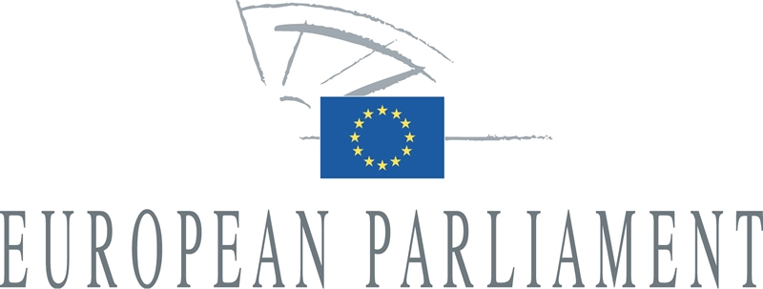 | 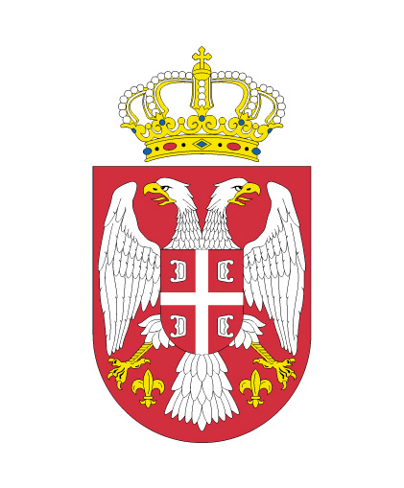
Delegation for relations with Albania, Bosnia and Herzegovina, Serbia, Montenegro and Kosovo | National Assembly  Republic of Serbia  Committee on European Integration

7th Inter-parliamentary Meeting
18-19 March 2013, Brussels

JOINT STATEMENT
by the Chairpersons of the Delegations

At the conclusion of the 7th European Parliament – National Assembly of the Republic
of Serbia Inter-parliamentary Meeting, held in Brussels on 18-19 March 2013, the two delegations:

- Stated that the start of EU accession negotiations in June 2013 is an achievable objective for Serbia; urged the Serbian government to continue democratic, systemic and socio-economic reforms that will allow it to take on and implement effectively the obligations of membership; concluded that Serbia has taken many steps towards the normalization of relations with Pristina and has made efforts to sufficiently fulfil the political criteria and conditions of the Stabilization and Association Process;
- Reiterated their invitation to the only remaining EU Member State - Lithuania - to complete the ratification of the Stabilisation and Association Agreement (SAA) between the EU and Serbia in order to further intensify the bilateral relations; and recalled that the SAA was signed in 2008;
- Welcomed the developing Belgrade-Pristina Dialogue and the engagement expressed by the Serbian government; called for full implementation of the agreements reached so far by both parties; commended the proactive role and leadership of the High Representative in facilitating the dialogue; look forward to further progress in the talks and particularly urged both sides to actively engage in efforts to resolve the issues of missing persons, properties and return of internally displaced persons; strongly supported the investigations on the issues raised in the Report of Council of Europe Rapporteur Dick Marty conducted by the EULEX Special Investigative Task Force; welcomed the instruction of the Serbian government on the implementation of the agreement on inclusive regional cooperation, the decision to appoint a liaison officer respectively to Pristina and Belgrade EU offices, and the signature of the IBM agreement and the first steps of its implementation;

- Reiterated the importance of regional cooperation and good neighbourly relations for Western Balkan countries in their path towards European integration; called on the authorities to continue to support the Initiative for REKOM, an initiative which is an important mechanism for the reconciliation process for the countries of the former Yugoslavia; called on the presidents of the countries which are yet to appoint their representatives to the REKOM to do so immediately so as to finalize the process of REKOM's formal establishment;
- Emphasised the importance of the oversight function of parliaments and the engagement of civil society in the Dialogue process; stressed the responsibility of participants during the dialogue process to transmit results of the dialogue in a clear and credible manner to the citizens;
- Welcomed the government's commitment for the fight against corruption and organised crime, which is a crucial matter for the development of the country, including its European integration process; stressed the importance of strengthening both independent institutions and judicial authorities, particularly the Anti-corruption Agency and the Anti-corruption Prosecutor and by improving inter-agency coordination; emphasised the importance of establishing a solid track record of investigations and convictions of high profile corruption cases in view of the early opening of chapters 23 and 24 during the accession negotiations; welcomed the political will to create an atmosphere for the fight against corruption, especially in cases of high profile corruption cases; stressed the importance to adopt, along with neighbouring countries, a regional strategy to tackle corruption and organised crime in order to handle these problems more effectively;
- Noted that Serbia is developing a new strategy on judicial reform and expressed their support for the efforts to work out a new court system in order to improve the efficiency and independence of the whole judicial system;
- Took note of the effort by the new government to address the concerns expressed by the European Parliament regarding the call for immediate revision of Article 359 of the Criminal Code, but expressed concern that similar provisions have been included in Article 234 of the Code; emphasised that the provisions of the new Article 234 may not be applied for unjustified prosecution of private sector operators or of responsible persons, or for the reclassification of unjustified existing cases and called on the authorities to cease all criminal procedures against these persons; the cases of the unjustly frozen assets should be solved as soon as possible, as the current situation aggravates the state of the Serbian economy;
- Welcomed the successful start of the Restitution Agency's work and emphasised the importance of guaranteeing an effective and non-discriminative procedure during the implementation of the Act on Restitution and the Act on Rehabilitation; called on the Agency to apply a detailed and accurate procedure in order to prevent future injustices while correcting historical injustice;
- Stressed that the ICTY has played an important role in the process of regional reconciliation; welcomed, in this respect, Serbia's cooperation with the ICTY and encouraged further cooperation with the Tribunal; supported, furthermore, the urgency to conduct thorough investigations and prosecution of all persons engaged in the support networks which enabled fugitives to remain at large for a long period of time, particularly in the military and civilian security services; stressed that it is of the utmost importance to ensure credibility and professionalism in the Witness Protection Programme (WPP) as well as to provide it with adequate resources so as to ensure the judiciary can effectively continue its proceedings on war crimes;

- Expressed their concerns about the legal uncertainty with regards to the autonomy of Vojvodina, called on the government to start immediate talks with the government of the Autonomous Province of Vojvodina so as to find solutions which respect the principles of the rule of law and subsidiarity; underlined that Vojvodina is a great example of a multiethnic, multicultural and multilingual region in Europe;
- Emphasised the importance of the fight against discrimination in all forms and against all vulnerable groups, in particular women, minorities, including national minorities, LGBT persons and persons with disabilities; called on the authorities to continue to align and implement the legislation on anti-discrimination with the EU acquis; welcomed the readiness of both the Serbian Parliament and the European Parliament to jointly organize a conference on the protection of LGBT persons in June this year, in Belgrade; expressed support to on-going reporting on prosecutions and final convictions for offences related to discrimination; welcomed introduction of Hate crime in Serbian Criminal Code; welcomed the positive action undertaken by the Ombudsman and the Commissioner for Equality to promote these values in the Serbian society;
- Regretted the recent incidents in Vojvodina involving the attacks on members of the national minorities, who are full and equal citizens of Serbia; therefore called on the authorities to implement existing legislation, to fully investigate the cases concerned, to collect reliable data, and to refrain from discrimination during the judicial process in order to prevent these cases in the future;
- Welcomed the protection of national, ethnic and cultural minorities in the legislative framework of Serbia, particularly in relation to the fair representation of minorities in public administration, the judiciary and the police forces; underlined the importance of the Law on national councils of national minorities, its progressive content and the necessity for its wide implementation and application with full respect to their competencies; insisted that consistent and prompt measures ought to be taken to ensure an unrestricted access to a quality education in minority languages on both a state and provincial level; suggested that procedural transparency and open communication towards the citizens in the media will ease tensions and promote reconciliation between the different nationalities and ethnicities in the region;
- Underlined the need to improve the position of the Roma population; recognised that some progress has been made such as the increase in the enrolment rate of Roma children in the education system; however more concentrated and targeted efforts are needed;
- Recalled that a vigorous, professional and independent media is an essential element of a democratic system; called on the authorities to ensure and promote freedom of information and media, safety and independence of journalists and of investigative journalism, in particular for journalists who are researching corruption and organized crime; ensuring the independence of the media from political pressure and providing them with a safe environment to conduct their work; expressed regret about the recent incident in Niš in which a group of men threatened members of the OSCE mission to Serbia during a debate on a draft law on public information;
- Reaffirmed their staunch support for the visa liberalisation for Western Balkan countries; which represents the most visible and concrete achievement of the European integration process in the region; called on Serbia and EU Member States affected to tackle the issue of bogus asylum applicants and to do their utmost to strictly implement all the necessary criteria and measures needed for visa free travel to Schengen countries;

- Welcomed the presentation of the Renewable Energy Action plan which aims to give concrete measures by which Serbia hopes to implement its commitment made in the framework of the Energy Community Treaty to consume 27% of overall energy from renewables by 2020; encouraged the development of a legislative and administrative framework in order to create an attractive economic environment for foreign investors in the fields of renewable energies and energy efficiency;
- Called on Serbia during its presidency as chair of the Energy Community, and in accordance with its powers, to take all necessary steps to bring the Energy Strategy, adopted by the Ministerial Council of the Energy Community in Budva on 18 October 2012, in line with the EU environmental standards and climate goals, also ensuring that all relevant stakeholders, including civil society organisations, are included in the consultation process; proposed to establish a network of parliamentary energy committees of the Western Balkan countries and other neighbouring countries in the region, with the aim of improving relations and effective cooperation among the countries of the Western Balkans;
- Raised concerns about the recent food safety crisis and highlighted the importance of health and food safety and the need to discuss these issues in an open and transparent manner and in full compliance with EU standards.

