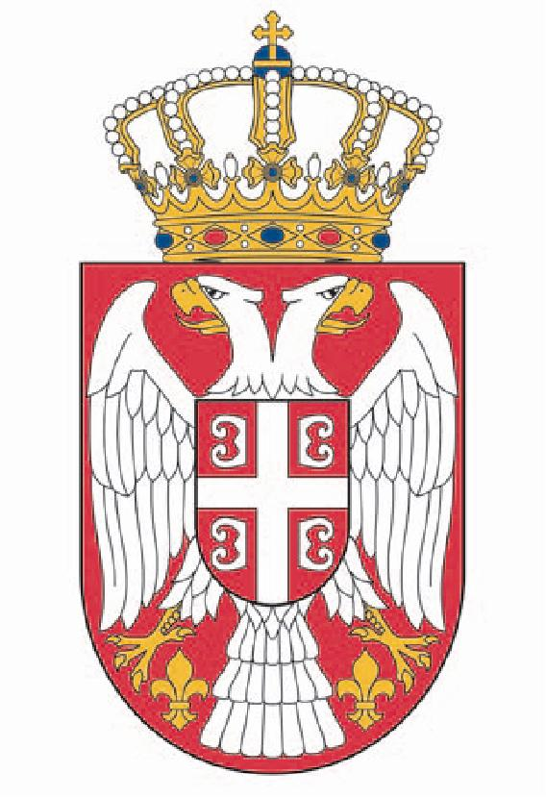
Republic of Serbia
National Assembly
Speaker

Belgrade, 13 September 2011

NOVAK DJOKOVIC

Dear Nole,

Please accept my most heartfelt congratulations on winning the US OPEN and once again proving you are the best in the world! I wish you many more victories and personal happiness!

SPEAKER

Prof. Dr Slavica Djukic-Dejanovic m.p.

