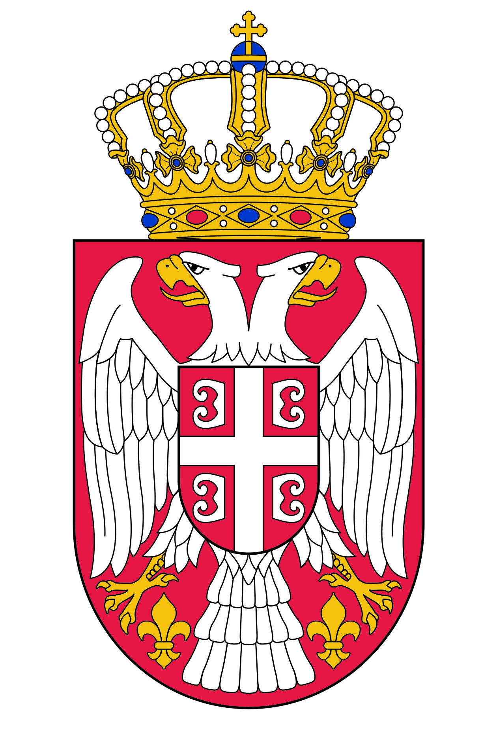
NATIONAL ASSEMBLY OF THE
REPUBLIC OF SERBIA

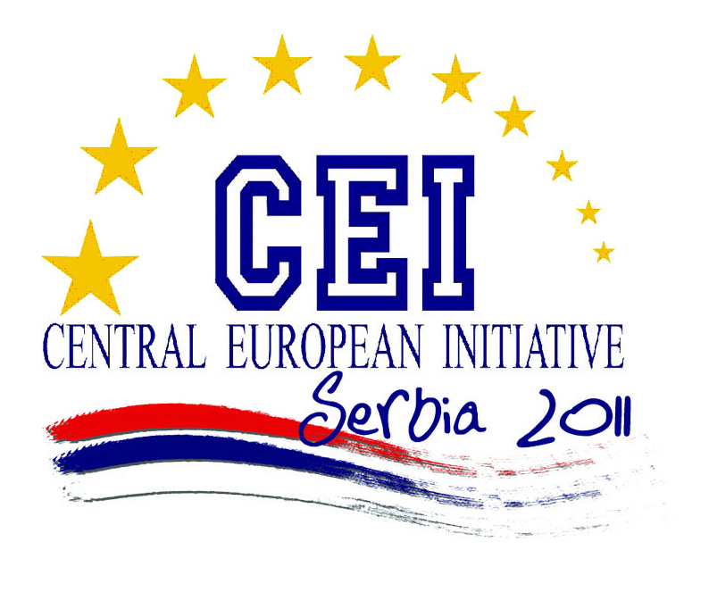

PARLIAMENTARY COMMITTEE OF THE CEI PD
Belgrade, 19 – 22 May 2011

NATIONAL ASSEMBLY OF THE REPUBLIC OF SERBIA

FINAL DECLARATION

Confirming one of the most important objectives of the CEI, building of Europe, a political, economic and cultural community without divisions and with the inclusion of all countries of the continent, ,
Reiterating the conclusions of the Thessaloniki Summit and the messages contained in the Thessaloniki Declaration and Agenda, that promote the principle of an open door for the candidate and potential candidate countries for EU membership,
Having in mind the importance of positive incentives that a clear and certain European perspective provides to non-EU CEI Member States for furthering structural reforms and alignment of the national legislation with the EU acquis,
Fully aware of the importance the EU membership perspective provides for the Western Balkan countries in terms of stability of the region and development of good neighborly relations and cooperation, and positive developments in this regard,

Emphasizing the key role that the European integration and advancements process in the Western Balkans plays for the whole region,
Concerned about the environmental disaster resulting from the leakage of radioactive material from the Fukushima nuclear power plant (Japan)
Having regard the importance of sustainable development and preservation of the environment, for the protection of lives and health of people,

Parliamentary Committee of the CEI Parliamentary Dimension

Notes the significant progress achieved by the non-EU CEI Member States, in terms of structural reforms and the progress in approaching the EU and the political, economic and social commitments that have been made in the last few years to set the stage for the European integration project;

Particularly welcomes the progress of the South East European countries achieved in the European integration process, and invites the European Union to take appropriate concrete steps aimed at bring them closer to the EU;
Welcomes the progress made in promoting good neighborly relations among the countries of in the Western Balkans as an important prerequisite for their association with the EU;

Underlines the importance of continuation of reforms and meeting EU standards and norms as a necessary condition for EU accession;

Considers that cooperation with the European Union and its institutions is one of the main priorities of the CEI, and looking ahead to the signing of a cooperation agreement between the European Commission and the CEI, and welcoming the fact that the conclusion of Croatia s negotiations with the EU is within reach, believes that the same process should be opened with other countries of the region;

Supports the additional efforts of the Republic of Serbia in fulfilling all the obligations concerning European integration aimed at acquiring candidate status and the beginig of negotiations on EU membership;

Points out the importance of introducing more effective security measures in the use of nuclear energy and greater security of its exploitation;
Emphasizes the importance of using alternative and renewable sources of energy and calls for directing more additional efforts in their research and application;
Underlines the importance of providing state subsidies for more environmentally friendly vehicles (electric drive, etc..) in order to protect the environment;

Calls for the promotion of international research projects, which actively involve universities and research institutions of CEI member States;

Emphasizes the importance of closer cooperation between CEI member states having in mind global and regional dimension of environmental protection and energy policy issues;
Calls for additional efforts for the purpose of achieving the aim of sustainable development of the member states;
Indicates the need for further strengthening of closer cooperation with other regional and global organizations;

Insist on strengthening efforts to establish better communications between the CEI and the European Commission;

Insists on the implementation of Article 25(1) of the CEI “Guidelines and Rules of Procedure” by organising a meeting of the Foreign Ministers of Serbia, Montenegro, Ukraine and Italy (the “Enlarged Troika”) with the Chairpersons of the Parliamentary Delegations of these countries, in the course of the meetings of the Ministers of Foreign Affairs to be held in Trieste on 10 June 2011;

Urges the governments of the CEI Member States to examine, at the meeting of Foreign Ministers to be held in Trieste on 10 June 2011, in the framework of a possible meeting “Enlarged governmental Troika” with “Enlarged parliamentary Troika” the advisability of fostering a debate on the possible enlargement of the territorial dimension of the CEI;

