Z A K O N
O POTVRĐIVANjU OKVIRNOG SPORAZUMA O ZAJMU LD 2070 (2020) IZMEĐU BANKE ZA RAZVOJ SAVETA EVROPE I REPUBLIKE SRBIJE ZA PROJEKTNI ZAJAM - STUDENTSKO STANOVANjE
Član 1.
Potvrđuje se Okvirni sporazum o zajmu LD 2070 (2020) između Banke za razvoj Saveta Evrope i Republike Srbije za projektni zajam - Studentsko stanovanje, koji je potpisan u Beogradu 7. jula 2021. godine i u Parizu 1. jula 2021. godine, u originalu na engleskom jeziku.
Član 2.
Tekst Okvirnog sporazuma o zajmu LD 2070 (2020) između Banke za razvoj Saveta Evrope i Republike Srbije za projektni zajam - Studentsko stanovanje, u originalu na engleskom jeziku i u prevodu na srpski jezik glasi:



LD 2070 (2020)

FRAMEWORK LOAN AGREEMENT

between

COUNCIL OF EUROPE DEVELOPMENT BANK

and

the REPUBLIC OF SERBIA

Student housing

- Project Loan -
TABLE OF CONTENTS
1. INTERPRETATION 5
1.1 Definitions 5
1.2 Construction 8
1.3 Headings 8
1.4 Rounding 8
2. CONDITIONS 8
3. PURPOSE 9
4. FINANCIAL CONDITIONS 9
4.1 Loan Amount 9
4.2 Disbursement Amount 9
4.3 Disbursement Procedure 9
4.4 Disbursement Period 10
4.5 Disbursement Conditions 10
4.6 Repayment 11
4.7 Prepayment 11
4.8 Interest Determination 12
4.9 Default Interest Rate 12
4.10 Market Disruption Event 12
4.11 Payments 13
5. PROJECT IMPLEMENTATION 14
5.1 Duty of Care 14
5.2 Allocation Period 14
5.3 Project Costs 14
5.4 Project Specific Undertakings 14
5.5 Procurement 15
5.6 Environmental and Social Safeguards 15
5.7 Human Rights 15
5.8 Integrity 15
5.9 Visibility 16
6. MONITORING 16
6.1 Reporting 16
6.2 Visits 17
6.3 Audit 17
6.4 Project Information 17
6.5 Borrower Information 17
6.6 Financial Covenants 17
7. PARI PASSU 18
7.1 Ranking 18
7.2 Security 18
7.3 Clause by Inclusion 19
7.4 Prepayment to Third Parties 19
8. REPRESENTATIONS AND WARRANTIES 19
9. THIRD PARTIES 20
10. NON-WAIVER 20
11. TRANSFER 20
12. ILLEGALITY 20
13. NO HARDSHIP 20
14. GOVERNING LAW 21
15. DISPUTES 21
16. PERSONAL DATA PROTECTION 21
17. NOTICES 21
18. TAXES AND EXPENSES 23
19. DISCHARGE 23
20. ENTRY INTO FORCE 23
APPENDIX 1 25
APPENDIX 2 28
APPENDIX 3 30
APPENDIX 4 32
APPENDIX 5…………………………… ………………………………………………………..33

COUNCIL OF EUROPE DEVELOPMENT BANK, international organisation with its headquarters at 55, Avenue Kléber, 75116 Paris (France) (hereinafter, the “CEB” or the “Bank”), on the one hand,
and
The REPUBLIC OF SERBIA, (hereinafter, the “Borrower” and together with the CEB, the “Parties” and each a “Party”), on the other hand,
WHEREAS
(A) Having regard to the loan application submitted by by the Republic of Serbia through its Ministry of Finance on 1 October 2020, approved by the CEB’s Administrative Council on 13 November 2020,
(B) Having regard to the Third Protocol dated 6 March 1959 to the General Agreement on Privileges and Immunities of the Council of Europe dated 2 September 1949,
(C) Having regard to the CEB’s Loan Regulations, as adopted by the CEB’s Administrative Council Resolution 1587 (2016) (hereinafter, the “Loan Regulations”),
(D) Having regard to the CEB’s Loan and Project Financing Policy, as adopted by the CEB’s Administrative Council Resolution 1617 (2020) (hereinafter, the “Loan Policy”),
(E) Having regard to the CEB’s Environmental and Social Safeguards Policy, as adopted by the CEB’s Administrative Council Resolution 1588 (2016) (hereinafter, the “Environmental and Social Safeguards Policy”),
(F) Having regard to the CEB’s Procurement Guidelines, as adopted by the CEB’s Administrative Council in September 2011 (hereinafter, the “Procurement Guidelines”),
(G) Having regard to the CEB’s Regulation on a system for the protection of personal data at the CEB, as adopted by CEB’s Administrative Council in September 2011 (hereinafter, the “Personal Data Protection Regulation”),
(H) Having regard to the CEB’s Anti-corruption Charter, as adopted by CEB’s Administrative Council in March 2007, and
(I) Having regard to the CEB’s Policy on Non-compliant/Uncooperative Jurisdictions, as adopted by CEB’s Administrative Council Resolution 1608 (2019),
HEREBY AGREE AS FOLLOWS:
1 INTERPRETATION
1.1 Definitions
The following terms shall have the meaning indicated below, except as the context requires otherwise:
“Agreement” means this framework loan agreement, including its appendices.
“Allocation” means the commitment of a Tranche by the Borrower to the eligible component parts of the Project/Sub-projects even if such Tranche has not yet been paid out under the Project.
“Allocation Period” has the meaning specified under Sub-clause 5.2.
“Business Day” means:
In relation to payments in Euro, any day on which TARGET 2 (the Trans European Automated Real-time Gross Settlement Express Transfer system) is operating.
“Certificate” has the meaning specified under Sub-clause 4.5 and the form stipulated under Appendix 4 hereto.
“Closing Date” means the date specified under Appendix 1 hereto from which no further disbursements under the Loan may take place. Such date may be modified upon prior written consent of both Parties, by means of an exchange of letters.
“Completion Report” has the meaning specified under Sub-clause 6.1(b).
“Cross-Default Event” has the meaning specified under Sub-clause 6.6.
“Currency” means, for the purposes of the Agreement, Euro.
“Day Count Convention” means the convention for determining the number of days between two dates and the number of days in a year specified in the relevant Disbursement Notice.
“Debt Instrument” means (i) any loan or other form of financial indebtedness; (ii) an instrument, including any receipt or statement of account, evidencing or constituting an obligation to repay a loan, deposit, advance or similar extension of credit (including without limitation any extension of credit under a refinancing or rescheduling agreement), (iii) a bond, note, debt security, debenture or similar written evidence of financial indebtedness; or (iv) an instrument evidencing a guarantee of an obligation constituting financial indebtedness of another.
“Default Interest Rate” has the meaning specified under Sub-clause 4.9.
“Disbursement Date” means the date on which a Tranche is scheduled to be disbursed pursuant to the applicable Disbursement Notice.
“Disbursement Notice” has the meaning specified under Sub-clause 4.3(b).
“Disbursement Request” has the meaning specified under Sub-clause 4.3(a).
“Effective Date” means the date of entry into force of the Agreement resulting from Clause 20.
“EU” means the European Union.
“EURIBOR” means the percentage rate quoted by any financial news provider acceptable to the CEB at or about 11.00 a.m. Brussels time on the Interest Determination Date as the Euro wholesale funding rate administrated by the European Money Market Institute (or any other entity which takes over the administration of that rate) for the same period as the relevant Interest Period.
If the relevant Interest Period is not the same as a period quoted by the relevant financial news provider, the applicable EURIBOR shall be the percentage rate resulting from a linear interpolation by reference to two (2) EURIBOR rates, one of which is applicable for a period of whole months next shorter and the other for a period of whole months next longer than the length of the relevant Interest Period.
“Euro” and the sign “EUR” means the lawful currency of the Member States of the EU which from time to time adopt it as their currency in accordance with the relevant provisions of the Treaty of the EU and the Treaty on the Functioning of the EU or their succeeding treaties.
“European Convention on Human Rights” means the Convention for the Protection of Human Rights and Fundamental Freedoms dated 4 November 1950, CETS No. 5, as amended from time to time.
“European Social Charter” means the European Social Charter dated 3 May 1996, CETS No. 163, as amended from time to time.
“Final Beneficiaries” are specified under Appendix 1 hereto as the group benefitting from the social effects of the Project.
“Financial Covenants” has the meaning specified under Sub-clause 6.6.
“Fixed Interest Rate” means the interest rate per annum specified in the applicable Disbursement Notice.
“Floating Interest Rate” means the interest rate per annum determined by adding or subtracting the Spread specified in the applicable Disbursement Notice to or from, as the case may be, the Reference Rate.
For the avoidance of doubt, when the determination of the Floating Interest Rate results in a negative interest rate (due to a quoted negative Reference Rate, to the operation of a Spread that is subtracted from the Reference Rate or to any other circumstances), the interest to be paid by the Borrower for the Interest Period shall be deemed to be zero.
“Forecasted Expenditure” means the eligible costs planned to be incurred under the Project over the period of one (1) year.
“Incurred Expenditure” means the eligible costs incurred by the Project Implementing Entity.
“Interest Determination Date” means, for the purposes of determination of a Floating Interest Rate, the day falling two (2) Business Days prior to the first day of the Interest Period, unless otherwise specified in the relevant Disbursement Notice.
“Interest Payment Dates” means the dates for the payment of interest corresponding to the relevant Interest Period specified in the applicable Disbursement Notice.
“Interest Period” means the period commencing on an Interest Payment Date and ending on the day immediately prior to the following Interest Payment Date, provided that the first Interest Period applicable to each Tranche shall commence on the Disbursement Date and end on the day immediately prior to the next Interest Payment Date.
“Loan” means the loan granted to the Borrower by the CEB by means of the Agreement.
“Loan Amount” means the amount specified under Sub-clause 4.1.
“Market Disruption Event” has the meaning specified under Sub-clause 4.10.
“Material Adverse Change” means any event which, in CEB’s opinion, (i) materially impairs the Borrower’s ability to perform its financial obligations under the Agreement; (ii) adversely affects any Security provided by the Borrower or a third-party to secure the due performance of the Borrower’s financial obligations under the Agreement; or (iii) adversely affects any rights or remedies of the CEB under the Agreement.
“Maturity Date” means the last Principal Repayment Date for each Tranche specified in the applicable Disbursement Notice.
“Modified Following Business Day Convention” means a convention whereby if a specified date would fall on a day which is not a Business Day, such date would be the first following day that is a Business Day unless that day falls in the next calendar month, in which case that date would be the first preceding day that is a Business Day.
“Prepayment Confirmation” has the meaning specified under Sub-clause 4.7.
“Prepayment Costs” has the meaning specified under Sub-clause 4.7.
“Prepayment Date” has the meaning specified under Sub-clause 4.7.
“Prepayment Notice” has the meaning specified under Sub-clause 4.7.
“Principal Repayment Date(s)” means the date(s) for the repayment(s) of principal under each Tranche specified in the applicable Disbursement Notice.
“Principal Repayment Period” means with respect of each Tranche the period running from its Disbursement Date to its Maturity Date.
“Progress Report” has the meaning specified under Sub-clause 6.1(a).
“Prohibited Practices” has the meaning specified under Sub-clause 5.8(c).
“Project” means the eligible investment scheme(s) set forth under Appendix 1 hereto to be partially financed with the Loan approved by the CEB’s Administrative Council with reference LD 2070 (2020).
“Project Implementing Entity” (hereinafter, the “PIE”) means the legal entity that, by delegation of the Borrower, is in charge of the implementation of the Project.
“Project Implementing Unit” (hereinafter, the “PIU”) means the team appointed by the PIE in charge of the day-to-day management of the Project.
“Reference Rate” means EURIBOR for a Floating Interest Rate Tranche denominated in Euro.
“Sanction Lists” means (i) any economic, financial and trade restrictive measures and arms embargoes issued by the EU pursuant to chapter 2 of title V of the Treaty on European Union as well as article 215 of the Treaty on the Functioning of the European Union, as available on the official EU website or on any successor page, as amended and supplemented from time to time; or (ii) any economic, financial and trade restrictive measures and arms embargoes issued by the United Nations Security Council pursuant to article 41 of the UN Charter, as available on the official UN website or on any successor page, as amended and supplemented from time to time.
“Sanctioned Persons” means any individual or entity listed in and/or otherwise subject to one or more Sanction Lists.
“Security” means any agreement or arrangement creating a preferential rank, a preferential right of payment, a collateral or guarantee of any nature whatsoever which might confer enhanced rights upon third parties.
“Spread” means, in connection with Floating Interest Rate Tranches, the fixed-spread to the Reference Rate (being either plus or minus) specified in basis points in the applicable Disbursement Notice.
“Sub-project” means an eligible investment scheme to be financed under the Project as specified under Appendix 1 hereto.
“Tranche” means an amount disbursed or to be disbursed under the Loan.
1.2 Construction
Unless the context otherwise requires, references to:
(a) this Agreement shall be construed as references to this Agreement as supplemented, amended or restated from time to time;
(b) a Party or any other person includes its successors in title or permitted transferee;
(c) “Clauses”, “Sub-clauses” and “Recitals” shall be construed as references to clauses, sub-clauses and recitals respectively of this Agreement; and
(d) words importing the singular shall include the plural and vice-versa.
1.3 Headings
Headings in this Agreement have no legal significance and do not affect its interpretation.
1.4 Rounding
For the purposes of any calculations referred to in this Agreement:
(a) all percentages resulting from such calculations other than those determined through the use of interpolation will be rounded, if necessary, to the nearest one hundred-thousandth of a percentage point (e.g., 9.876541% (or .09876541) being rounded down to 9.87654% (or .0987654) and 9.876545% (or .09876545) being rounded up to 9.87655% (or .0987655));
(b) all percentages determined through the use of linear interpolation by reference to two (2) relevant Reference Rates will be rounded, if necessary, in accordance with the method set forth in subsection (a) above, but to the same degree of accuracy as the two (2) rates used to make the determination (except that such percentages will not be rounded to a lower degree of accuracy than the nearest one thousandth of a percentage point (0.001%)); and
(c) all currency amounts used in or resulting from the above calculations will be rounded, unless otherwise specified in the relevant Currency definition, to the nearest two decimal places in the relevant currency (with .005 being rounded upwards (e.g., .674 being rounded down to .67 and .675 being rounded up to .68).
2 CONDITIONS
The Loan is granted under the general conditions of the Loan Regulations and under the special conditions of the Agreement.
3 PURPOSE
The CEB grants the Loan to the Borrower, who accepts it, solely for the purpose of financing the Project as described under Appendix 1.
The proceeds of the Loan cannot be used for the financing of taxes (including VAT) , customs and other duties.
Any change to the way the Loan is applied that has not received the CEB’s prior written approval would constitute an event in the terms of Article 3.3 (h) of the Loan Regulations and may give rise to the early reimbursement, suspension or cancellation of the Loan under the terms of Articles 3.3 (Early reimbursement of disbursed loans), 3.5 (Suspension by the Bank of undisbursed loans) and 3.6 (Cancellation by the Bank of undisbursed loans) of the Loan Regulations.
4 FINANCIAL CONDITIONS
4.1 Loan Amount
The Loan Amount is:
THIRTY-TWO MILLION EUROS
EUR 32,000,000
4.2 Disbursement Amount
The Loan shall be disbursed in a minimum of two (2) Tranches.
The amount of each Tranche, except for the first Tranche, shall be determined according to the Incurred Expenditure and Forecasted Expenditure. The amount of the first Tranche shall not exceed twenty-five per cent (25 %) of the Loan Amount.
4.3 Disbursement Procedure
The disbursement of each Tranche is determined through the following procedure:
(a) Disbursement Request
Prior to each disbursement and upon prior consultation with CEB, the Borrower shall submit to the CEB a disbursement request substantially in the form set out under Appendix 3 hereto (hereinafter, a “Disbursement Request”).
A Disbursement Request shall specify the proposed:
(i) Currency(ies) and amount(s) for the Tranche;
(ii) Disbursement Date; such Disbursement Date shall be a Business Day falling at least five (5) Business Days after the date of the Disbursement Request;
(iii) Principal Repayment Date(s), including the Maturity Date, taking into account that the Principal Repayment Period for each Tranche shall not exceed twenty (20) years including a grace period not greater than five (5) years;
(iv) maximum Fixed Interest Rate or maximum Spread to the Reference Rate;
(v) Interest Period and Interest Payment Dates;
(vi) Day Count Convention and Business Days; and
(vii) Borrower’s account for payments.
Each Disbursement Request delivered to the CEB shall be irrevocable, unless otherwise agreed in writing by the CEB.
(b) Disbursement Notice
If the CEB receives a Disbursement Request that complies with the Disbursement Request requirements set out in Sub-clause 4.3(a) above, and if all other relevant Disbursement Conditions as defined in Sub-clause 4.5 (Disbursement Conditions) below have been fulfilled by the Borrower, the CEB shall deliver to the Borrower a disbursement notice substantially in the form set out under Appendix 3 hereto (hereinafter, a “Disbursement Notice”). Each Disbursement Notice shall be delivered at least two (2) Business Days before the proposed Disbursement Date.
A Disbursement Notice shall specify:
(i) the Currency(ies) and the amount(s) for the Tranche;
(ii) the Disbursement Date;
(iii) the Principal Repayment Period and Principal Repayment Date(s), including the Maturity Date;
(iv) the Fixed Interest Rate or the Spread to the Reference Rate;
(v) the Interest Period and the Interest Payment Dates;
(vi) the Day Count Convention and the Business Days; and
(vii) the Borrower’s and the CEB’s accounts for payments.
A Disbursement Notice matching the elements included in a Disbursement Request shall constitute an irrevocable and unconditional commitment on the part of the Borrower to borrow from the CEB and on the part of the CEB to disburse to the Borrower the Tranche under the terms and conditions specified in the Disbursement Notice.
Notwithstanding the above, if the CEB has not delivered a Disbursement Notice within ten (10) Business Days following the receipt of a Disbursement Request, the relevant Disbursement Request shall be deemed as cancelled.
4.4 Disbursement Period
Unless otherwise agreed in writing by the CEB, the Borrower shall not be entitled to:
(i) the issue of a Disbursement Request for the first Tranche beyond twelve (12) months after the execution of the Agreement by the Parties;
(ii) the issue of any further Disbursement Request beyond eighteen (18) months after the last disbursement; or
(iii) the issue of any further Disbursement Request beyond the day falling fifteen (15) Business Days before the Closing Date.
4.5 Disbursement Conditions
(a) Conditions precedent to the Disbursement Request for the first Tranche:
(i) Legal opinion in English issued by the Ministry of Justice of the Borrower confirming to the CEB’s satisfaction, substantially in the form set out under Appendix 2 hereto, that the Agreement has been duly executed by authorised representatives of the Borrower and that the Agreement is valid, binding and enforceable in accordance with its terms in the Borrower’s jurisdiction.
(ii) Evidence in English (e.g., power of attorney, etc.) to the CEB’s satisfaction of the person(s) authorised to execute the Agreement and the Disbursement Requests on behalf of the Borrower, together with the authenticated specimen of the signature(s) of such person(s).
(iii) A Certificate from the Borrower in the form of Appendix 4 hereto, signed by the person(s) authorised to execute the Disbursement Requests on behalf of the Borrower and dated not earlier than a date falling five (5) Business Days before the Disbursement Request.
(iv) Any other condition applicable to the Loan/Project.
(b) Conditions precedent to any further Disbursement Request:
(i) Evidence in English (e.g., Power of Attorney, etc.) to the CEB’s satisfaction of the person(s) authorised to execute the Disbursement Requests on behalf of the Borrower, together with the authenticated specimen of the signature(s) of such person(s).
(ii) Progress Report confirming to the CEB’s satisfaction the full Allocation of previous Tranche.
(iii) A Certificate from the Borrower in the form of Appendix 4, signed by the person(s) authorised to execute the Disbursement Requests on behalf of the Borrower and dated not earlier than a date falling five (5) Business Days before the Disbursement Request.
4.6 Repayment
On any Principal Repayment Date, the Borrower shall repay the principal of each Tranche due on that Principal Repayment Date in accordance with the terms set forth in the applicable Disbursement Notice.
4.7 Prepayment
(a) Mechanics
If in any event specified in this Agreement referring to this Sub-clause the Borrower ought to prepay all or part of a Tranche or in the event of voluntary prepayment, the Borrower shall give at least a two (2) months prior written notice to the CEB (hereinafter, the “Prepayment Notice”) specifying the amounts to be prepaid, the date on which the prepayment will take place (hereinafter, the “Prepayment Date”) and, upon prior consultation with the CEB, the Prepayment Costs. The Prepayment Date shall fall on an Interest Payment Date, unless otherwise agreed in writing by the CEB.
Upon receipt of the Prepayment Notice, the CEB shall send a written notice to the Borrower (hereinafter, the “Prepayment Confirmation”), not later than fifteen (15) Business Days prior to the Prepayment Date, indicating the accrued interest due thereon and the Prepayment Costs in accordance with Sub-claus 4.7 (b).
A Prepayment Confirmation matching all the elements included in the Prepayment Notice shall constitute an irrevocable and unconditional commitment on the part of the Borrower to prepay the relevant amounts to the CEB under the terms and conditions specified in the Prepayment Confirmation. If the CEB has not delivered a Prepayment Confirmation within the deadline specified above, the relevant Prepayment Notice shall be deemed as cancelled.
If the Borrower partially prepays a Tranche, the prepaid amount shall be applied pro rata to each outstanding principal repayment. In such an event, the Prepayment Confirmation shall accordingly include an adjusted repayment schedule which shall be binding on the Borrower.
(b) Prepayment Costs
The costs resulting from prepayment in accordance with Sub-clause 4.7 (a) (hereinafter, the “Prepayment Costs”) shall be determined by the CEB on the basis of the costs to it of redeploying the amount to be prepaid from the Prepayment Date to the Maturity Date, including any related costs, such as unwinding any underlying hedging arrangements. The costs of redeployment will be established on the basis of the difference between the original rate and the redeployment rate, which shall be determined by the CEB on the basis of market conditions on the date of the Prepayment Notice.
4.8 Interest Determination
The Borrower shall pay interest on the principal of each Tranche from time to time outstanding during each Interest Period at the Fixed Interest Rate/Floating Interest Rate specified in the applicable Disbursement Notice.
Interest shall (i) accrue from and including the first day of the Interest Period to but excluding the last day of such Interest Period; and (ii) be due and payable on the Interest Payment Dates specified in the applicable Disbursement Notice. Interest shall be calculated on the basis of the Day Count Convention specified in the relevant Disbursement Notice.
In the case of Floating Interest Rate Tranches, the CEB shall determine on each Interest Determination Date the interest rate applicable during the relevant Interest Period in accordance with the Agreement and promptly give notice thereof to the Borrower. Each determination by the CEB shall be final, conclusive and binding upon the Borrower unless shown by the Borrower to the satisfaction of the CEB that any such determination has involved manifest error.
4.9 Default Interest Rate
In the event that the Borrower fails to pay, in full or in part, any amount under the Agreement, and notwithstanding any other recourse available to the CEB under the Agreement or otherwise, the Borrower shall pay interest on such unpaid amounts from the due date until the date of receipt of such payment by the CEB at the interest rate per annum equal to the one-month EURIBOR quoted on the due date plus two hundred basis points (200 bps) (hereinafter, the “Default Interest Rate”).
The applicable Default Interest Rate shall be updated every thirty (30) calendar days.
4.10 Market Disruption Event
The CEB shall promptly, upon becoming aware of it, notify to the Borrower that a Market Disruption Event has occurred.
For the purposes of the Agreement, “Market Disruption Event” refers to the following circumstances:
(a) The relevant financial news provider referred to under the EURIBOR definition does not quote any percentage rate or its corresponding screen rate page is not accessible.
Under such a Market Disruption Event, the applicable EURIBOR shall be the percentage rate per annum determined by the CEB to be the arithmetic mean of the rates at which loans in Euro, in an amount identical or nearest comparable to the Loan amount in question and for a period identical or nearest comparable to the relative Interest Period, are offered on the Interest Determination Date by three (3) leading banks in the EU interbank market selected by the CEB. If at least two (2) quotations are provided, the applicable EURIBOR for that Interest Determination Date shall be the arithmetic mean of all quotations provided.
If only one (1) or no quotation is provided, the applicable EURIBOR shall be the percentage rate per annum determined by the CEB to be the arithmetic mean of the rates at which loans in Euro, in an amount identical or nearest comparable to the Loan amount in question and for a period identical or nearest comparable to the relative Interest Period, are offered on the second Business Day after the beginning of the relevant Interest Period by major banks in the EU interbank market selected by the CEB.
(b) The CEB determines that it is not possible to determine the applicable Reference Rate in accordance with paragraph (a) above.
Under such a Market Disruption Event, the applicable Floating Interest Rate shall be replaced by the rate that expresses as a percentage rate per annum the cost to the CEB of funding the Loan from whatever source the CEB may reasonably select.
(c) At any time between the delivery of a Disbursement Notice and the Disbursement Date the CEB reasonably determines that there are exceptional and unexpected circumstances of an economic, financial, political or other external nature adversely affecting the CEB’s access to its sources of funding.
Under such a Market Disruption Event, the CEB shall be entitled to cancel at no cost the scheduled disbursement.
In the case of the Market Disruption Events set forth under paragraphs (a) and (b) above:
(i) If the Borrower so requires, the Parties, acting in good faith, shall enter into negotiations for a period of not more than thirty (30) calendar days in order to agree on an alternative to the applicable EURIBOR. If no agreement is reached, the Borrower shall proceed with prepayment on the next Interest Payment Date in the terms provided under Sub-clause 4.7.
(ii) The CEB shall have the right, acting in good faith and in consultation with the Borrower to the extent reasonably practicable, to change the duration of any subsequent Interest Period to thirty (30) calendar days or less by sending to the Borrower a notice thereof. Any such change to an Interest Period shall take effect on the date specified by the CEB in such notice.
(iii) For the avoidance of doubt, items (i) and (ii) above shall only apply in circumstances where the Borrower shall pay interest on the principal of a Tranche outstanding at a Floating Interest Rate.
If the CEB determines that the relevant Market Disruption Event no longer exists, then, subject to any further Market Disruption Event occurring or existing, the Floating Interest Rate and/or Interest Period applicable to any relevant Tranche shall revert, from the first day of the following Interest Period to being calculated in accordance with the Floating Interest Rate and Interest Period specified in the relevant Disbursement Notice.
4.11 Payments
All the amounts due by the Borrower under this Agreement are payable in the Currency of each Tranche to the CEB’s account indicated in the applicable Disbursement Notice. Any payment under this Agreement shall be made on a Business Day subject to the Modified Following Business Day Convention. Any payment shall be deemed paid when the CEB has received the amount on its account.
The Borrower or the bank instructed by the Borrower, as the case may be, shall send a written payment notice to the CEB at least five (5) Business Days before payment of any amounts due under this Agreement.
All payments to be made by the Borrower under this Agreement shall be calculated and be made without (and free and clear of any deduction for) set-off or counterclaim.
If the CEB receives a payment that is insufficient to discharge all the amounts then due and payable by the Borrower under this Agreement, the CEB shall apply that payment in or towards payment of:
(i) first, any fees, costs, charges or expenses due but unpaid under this Agreement;
(ii) secondly, any accrued interest due but unpaid under this Agreement,
(iii) thirdly, any principal due but unpaid under this Agreement; and
(iv) fourthly, any other sum due but unpaid under this Agreement.
5 PROJECT IMPLEMENTATION
The Borrower shall implement the Project in accordance with the Agreement.
The Borrower designates Ministry of Education, Science and Technological Development as the PIE. The Borrower shall ensure that the PIE appoints a PIU appropriately staffed and equipped throughout the Project implementation period, to the satisfaction of CEB.
In any event, the Borrower remains solely liable to comply with its obligations under the Agreement.
Failure to comply with the undertakings set forth hereby under Clause 5 would constitute, irrespective of any other applicable provision of the Loan Regulations, an event in the terms of Article 3.3 (h) of the Loan Regulations and may give rise to (i) the relevant Sub-project expenditure declared ineligible for Allocation under the Project; and/or (ii) the early reimbursement, suspension or cancellation of the Loan, in whole or in part, under the terms of Articles 3.3 (Early reimbursement of disbursed loans), 3.5 (Suspension by the Bank of undisbursed loans) and 3.6 (Cancellation by the Bank of undisbursed loans) of the Loan Regulations.
5.1 Duty of Care
The Borrower shall apply all care and diligence, and shall exercise all typically used means (including, but not limited to, legal, financial, managerial and technical) required for the proper implementation of the Project.
5.2 Allocation Period
The Borrower shall allocate each Tranche to the Project within twelve (12) months after the relevant Disbursement Date (hereinafter, the “Allocation Period”), unless otherwise agreed in writing by the Borrower and CEB.
If a Tranche disbursed by the CEB is not allocated to the Project or is only partially allocated to it within the Allocation Period, the Borrower shall proceed with prepayment of the unallocated amounts on the next Interest Payment Date in the terms provided under Sub-clause 4.7 unless otherwise agreed between the Borrower and CEB.

5.3 Project Costs
The Tranches disbursed under the Loan shall not exceed sixty-six per cent (66%) of the total eligible costs of the Project specified under Appendix 1 hereto. If the Tranches disbursed under the Loan exceed the above 66% (by reduction of the total eligible costs or otherwise), the Borrower shall proceed with prepayment of the surplus on the next Interest Payment Date in the terms provided under Sub-clause 4.7.
Should the total eligible costs of the Project increase or be revised for whatever reason, the Borrower shall ensure that the additional financial resources for the completion of the Project are available without recourse to the CEB. The plans to finance the increased costs shall be communicated to the CEB without delay.
5.4 Project Specific Undertakings
The Borrower shall ensure that:
(i) all the land, real property rights and permits required for the implementation of the Project are timely available;
(ii) all assets and plants under the Project are permanently insured, maintained and operated in accordance with international best practices; and
(iii) any other requirement specified in Appendix 1 (“Specific Conditions”) hereto is complied with.
5.5 Procurement
Procurement of supplies, works and services to be financed under the Project shall comply with the CEB Procurement Guidelines.
5.6 Environmental and Social Safeguards
The Borrower through the PIE shall implement the Project in conformity with the requirements set forth in the Environmental and Social Safeguards Policy. In particular, should the Project require an Environmental Impact Assessment (EIA) or an Environmental and Social Impact Assessment (ESIA) in accordance with the Environmental and Social Safeguards Policy, the Borrower shall notify the CEB and ensure that the EIA/ESIA is undertaken in accordance with the requirements of the Environmental and Social Safeguards Policy. The Borrower shall ensure that the relevant EIA/ESIA documentation is made available for the CEB’s review upon request.
5.7 Human Rights
The Borrower through the PIE and PIU shall ensure that the implementation of the Project does not give rise to a violation of (i) the European Convention on Human Rights; or (ii) the European Social Charter.
5.8 Integrity
The Borrower, directly or through the PIE and the PIU, undertakes that:
(a) it will institute and thereafter comply with internal policies, procedures and controls, in line with applicable legislation and international best practices, for the purpose of preventing the Borrower to become, in connection with the implementation of the Project or otherwise, an instrument for money laundering or terrorism financing;
(b) it will not make any Loan proceeds available to or for the benefit of, directly or indirectly, any Sanctioned Person;
(c) it will not commit, and no person, with its consent or prior knowledge, will commit, in connection with the implementation of the Project a Corrupt Practice, a Fraudulent Practice, a Coercive Practice, a Collusive Practice or an Obstructive Practice (hereinafter, together with money laundering, terrorism financing and making available any Loan proceeds to Sanctioned Persons referred to as the “Prohibited Practices”).
For the purposes of this Agreement:
(i) A “Corrupt Practice” means any act of offering, giving, receiving, or soliciting, directly or indirectly, anything of value to influence improperly the actions of another party.
(ii) A “Fraudulent Practice” means any act or omission, including a misrepresentation, that knowingly or recklessly misleads, or attempts to mislead, a party to obtain a financial or other benefit, or to avoid an obligation.
(iii) A “Coercive Practice” means any act of impairing or harming, or threatening to impair or harm, directly or indirectly, any party or the property of any party to influence improperly the actions of a party.
(iv) A “Collusive Practice” means any arrangement between two or more parties designed to achieve an improper purpose, including influencing improperly the actions of another party.
(v) An “Obstructive Practice” means, in relation to an investigation into a Coercive, Collusive, Corrupt or Fraudulent Practice, (a) any act of deliberately destroying, falsifying, altering or concealing of evidence material to the investigation; (b) any act of threatening, harassing or intimidating any party to prevent it from disclosing its knowledge of matters relevant to the investigation or from pursuing the investigation; and/or (c) any act intending to materially impede the exercise of the contractual rights of audit or access to information.
The Borrower, directly or through the PIE and the PIU undertakes to inform CEB if it should become aware of any fact or information suggestive of the commission of any such Prohibited Practice. For this purpose, the knowledge of any member of the PIE and the PIU shall be deemed the knowledge of the Borrower.
The Borrower, directly or through the PIE and the PIU undertakes:
(i) to take timely such action as the CEB may reasonably request to investigate and/or terminate any alleged or actual Prohibited Practice;
(ii) to facilitate any investigation that the CEB may conduct concerning any alleged or actual Prohibited Practice; and
(iii) to inform the CEB of the measures taken to seek damages from the persons responsible for any loss resulting from any such Prohibited Practice.
The Head of the PIU shall be responsible for contacts with the CEB for the purposes of this Sub-clause.
5.9 Visibility
The Borrower shall inform the Final Beneficiaries that the Project is partly financed by the CEB through appropriate means of communication such as dedicated notices in relevant websites, social media, press releases, brochures or the exhibit of billboards/plates on relevant Project sites/facilities. In any case, information to the Final Beneficiaries shall display in an appropriate way the CEB’s name and logo.
6 MONITORING
6.1 Reporting
(a) Progress Reports
The Borrower through the PIU shall send to the CEB a progress report (hereinafter, a “Progress Report”) (i) once a year, until the completion of the Project; and (ii) prior to every Disbursement Request, except for the Disbursement Request for the first Tranche.
Appendix 5 hereto provides a template specifying the minimum information required by the CEB. Alternative formats containing the same information may also be used.
(b) Completion Report
Upon completion of the Project, the Borrower through the PIU shall submit a completion report (hereinafter, a “Completion Report”) including an appraisal of the Project’s social impact.
Appendix 5 hereto provides a template specifying the minimum information required by the CEB. Alternative formats containing the same information may also be used.
6.2 Visits
The Borrower, directly or through the PIE and the PIU undertakes to favourably receive any monitoring/technical/evaluation visits, including by facilitating access to relevant Project sites/contractors, carried out by the CEB’s staff members or designated third parties.
6.3 Audit
Should the Borrower fail to comply with any of its undertakings under the Agreement, the Borrower undertakes to favourably receive any on-site audit, carried out by the CEB’s staff members or designated third parties, which shall be at the Borrower’s expense.
6.4 Project Information
The Borrower shall keep accounting records concerning the Project, which shall be in conformity with international standards, showing, at any point in time, the Project’s state of progress, and which shall record all operations made and identify the assets and services partially financed with the Loan.
The Borrower through the PIU shall deliver to the CEB in a timely manner any information or document concerning the financing or the implementation (including in particular environmental/social and procurement issues) of the Project as the CEB may reasonably require.
The Borrower through the PIU shall inform the CEB immediately of any event affecting the implementation of the Project, including but not limited to:
(i) any action or protest initiated or any objection raised by any third party or any complaint received by the Borrower or any litigation that is commenced or threatened against it with regard to procurement or environmental/social or other matters in connection with the Project; or
(ii) any enactment of or any amendment to any law, rule or regulation (or in the application or official interpretation of any law, rule or regulation) in connection with the Project.
Any event that may have a material adverse impact on the implementation of the Project would constitute an event in the terms of Article 3.3 (h) of the Loan Regulations and may give rise to the early reimbursement, suspension or cancellation of the Loan under the terms of Articles 3.3 (Early reimbursement of disbursed loans), 3.5 (Suspension by the Bank of undisbursed loans) and 3.6 (Cancellation by the Bank of undisbursed loans) of the Loan Regulations.
6.5 Borrower Information
The Borrower, directly or through the PIE shall deliver a summary every year, in a form and substance satisfactory to the CEB, of the Borrower’s annual budget and the related budget implementation and any such information on its general financial situation as the CEB may reasonably require from time to time, unless it is published on the official website of the Ministry of Finance or the National Bank of Serbia and available in English.
The Borrower directly or through the PIE and the PIU shall inform the CEB of any Material Adverse Change immediately after becoming aware thereof. Any Material Adverse Change would constitute an event in the terms of Article 3.3 (h) of the Loan Regulations and may give rise to the early reimbursement, suspension or cancellation of the Loan under the terms of Articles 3.3 (Early reimbursement of disbursed loans), 3.5 (Suspension by the Bank of undisbursed loans) and 3.6 (Cancellation by the Bank of undisbursed loans) of the Loan Regulations.
6.6 Financial Covenants
The Borrower shall inform the CEB if any Cross-Default Event occurs. Any Cross-Default Event would constitute an event in the terms of Article 3.3 (h) of the Loan Regulations and may give rise to the suspension, cancellation or early reimbursement of the Loan under the terms of Articles 3.3 (Early reimbursement of disbursed loans), 3.5 (Suspension by the Bank of undisbursed loans) and 3.6 (Cancellation by the Bank of undisbursed loans) of the Loan Regulations.
For the purpose of this Agreement, “Cross-Default Event” means a situation in which, following any default in relation thereto, the Borrower is required or is capable of being required or will, following expiry of any applicable contractual grace period, be required or be capable of being required to prepay, repay or terminate ahead of maturity any Debt Instrument or any commitment in connection with any Debt Instrument is cancelled or suspended.
7 PARI PASSU
Failure to comply with the provisions set forth below under Clause 7 would constitute an event in the terms of Article 3.3 (h) of the Loan Regulations and may give rise to the early reimbursement, suspension or cancellation of the Loan under the terms of Articles 3.3 (Early reimbursement of disbursed loans), 3.5 (Suspension by the Bank of undisbursed loans) and 3.6 (Cancellation by the Bank of undisbursed loans) of the Loan Regulations.
7.1 Ranking
The Borrower shall ensure that its payment obligations under this Agreement rank, and will rank, not less than pari passu in right of payment with all other present and future unsecured and unsubordinated obligations under any of its Debt Instruments.
In particular, the Borrower shall not make (or authorise) any payment in respect of any other such Debt Instrument (whether regularly scheduled or otherwise) if:
(i) the CEB makes a demand of early reimbursement under Article 3.3 (Early reimbursement of disbursed loans) of the Loan Regulations; or
(ii) an event or potential event of default under any unsecured and unsubordinated Debt Instrument of the Borrower or any of its agencies or instrumentalities has occurred and is continuing.
However, payment in respect of such Debt Instrument is possible if the Borrower:
(i) simultaneously pays; or
(ii) sets aside in a designated account for payment on the next Interest Payment Date
a sum equal to the same proportion of the principal outstanding under this Agreement as the proportion that the payment under such Debt Instrument bears to the total debt outstanding under that instrument.
For this purpose, any payment of a Debt Instrument that is made out of the proceeds of the issue of another instrument, to which substantially the same persons as hold claims under the Debt Instrument have subscribed, shall be disregarded.
7.2 Security
Should a Security be granted for the performance of any of the Borrower’s Debt Instruments, the Borrower shall timely inform the CEB of its intentions and shall, if so required by the CEB, provide to the CEB, within the deadline set forth in the CEB’s notice, identical or equivalent Security for the performance of its financial obligations under this Agreement.
This provision shall not apply to a Security:
(a) created on property at the time of purchase solely as security for the payment of the purchase price or for the payment of debt incurred for the purpose of financing the purchase of such property;
(b) securing a Debt Instrument maturing not more than one (1) year after the date on which it was originally incurred;
(c) previously approved by the CEB.
7.3 Clause by Inclusion
Should any of the Borrower’s Debt Instruments include a loss-of-rating covenant, a financial ratios covenant or pari passu provisions that are not included in the Agreement or that are stricter than any equivalent provision of this Agreement, the Borrower shall so inform the CEB and shall, at the request of the CEB by means of a written notice, execute within the deadline indicated in the CEB’s notice, an amendment to this Agreement to provide an equivalent provision in favour of the CEB.
7.4 Prepayment to Third Parties
Should the Borrower voluntarily prepay (for the avoidance of doubt, prepayment shall include a repurchase where applicable) in whole or in part any Debt Instrument and such prepayment:
(a) is not made within a revolving credit facility which remains open for drawing on the same terms after such prepayment; or
(b) is not made out of the proceeds of another Debt Instrument having a term at least equal to the unexpired term of the prepaid Debt Instrument,
the Borrower shall inform the CEB. In such an event, and upon the CEB’s request, the Borrower shall prepay to the CEB within two (2) months from any such prepayment the amounts disbursed under the Loan in accordance with Sub-clause in such proportion as the prepaid amount bears to the corresponding Debt Instrument.
8 REPRESENTATIONS AND WARRANTIES
The Borrower represents and warrants that:
(a) it is not and none of its officers, directors, agent or employees is a Sanctioned Person or is the subject of a final and irrevocable court ruling in connection with Prohibited Practices perpetrated in the exercise of its professional duties and none of them did or does enter into business relationships with Sanctioned Persons;
(b) its competent bodies have authorised it to enter into the Agreement and have given the signatory(ies) the authorisation therefor, in accordance with the laws, decrees, regulations, articles of association and other texts applicable to it;
(c) the execution and delivery of, the performance of its obligations under and compliance with the provisions of this Agreement do not:
(i) contravene or conflict with any applicable law, statute, rule or regulation, or any judgment, decree or permit to which it is subject;
(ii) contravene or conflict with any Debt Instrument or any other agreement binding upon it which might reasonably be expected to give rise to a Material Adverse Change;
(d) no event or circumstance is outstanding that constitutes a default under any Debt Instrument or any other agreement, which is binding on it or to which its assets are subject, which might reasonably be expected to give rise to a Material Adverse Change;
(e) no Security has been granted to a third party in breach of Sub-clause 7.2;
(f) no litigation, arbitration or administrative proceedings of or before any court, arbitral tribunal or agency which might reasonably be expected to give rise to a Material Adverse Change have (to the best of its knowledge and belief) been started or threatened against it; and
(g) it has received a copy of the Loan Regulations, the Loan Policy, the Environmental and Social Safeguards Policy, the Procurement Guidelines and the Personal Data Protection Regulation and has taken note thereto.
The above representations and warranties are deemed repeated on the date of signature of each Disbursement Request and on the date of each Certificate. Any change in relation to the above representations and warranties must, for the entire Loan period, be notified and any supporting documents provided to the CEB immediately after the Borrower having become aware of the change.
If any of the above representations and warranties is or proves to have been incorrect or misleading in any respect, this would constitute an event in the terms of Article 3.3 (h) of the Loan Regulations and may give rise to the suspension, cancellation or early reimbursement of the Loan under the terms of Articles 3.3 (Early reimbursement of disbursed loans), 3.5 (Suspension by the Bank of undisbursed loans) and 3.6 (Cancellation by the Bank of undisbursed loans) of the Loan Regulations.
9 THIRD PARTIES
The Borrower may not raise any fact relating, within the scope of the use of the Loan, to its relations with third parties in order to avoid fulfilling, either totally or partially, the obligations resulting from the Agreement.
The CEB may not be involved in disputes which might arise between the Borrower and third parties and the costs, whatever their nature, incurred by the CEB due to any claims, and in particular all legal or court costs, shall be at the expense of the Borrower.
10 NON-WAIVER
In no case, including delay or partial exercise, shall it be presumed that the CEB has tacitly waived any right granted to it by the Agreement.
11 TRANSFER
The Borrower may not transfer any of its rights and/or obligations under the Agreement without the prior written consent of the CEB.
The Borrower hereby gives its consent to any transfer by the CEB of all or part of its rights and/or obligations under the Agreement. CEB will inform the Borrower prior to such transfer.
12 ILLEGALITY
If it is or becomes unlawful in any jurisdiction for the CEB to make, maintain or fund the Loan or perform any of its obligations under this Agreement, this would constitute an event in the terms of Article 3.3 (h) of the Loan Regulations and may give rise to the suspension, cancellation or early reimbursement of the Loan under the terms of Articles 3.3 (Early reimbursement of disbursed loans), 3.5 (Suspension by the Bank of undisbursed loans) and 3.6 (Cancellation by the Bank of undisbursed loans) of the Loan Regulations.
13 NO HARDSHIP
Each Party hereby acknowledges that:
(i) unless otherwise contemplated in this Agreement, any applicable legal norm pursuant to which a Party may request the other Party to renegotiate the Agreement or may cease to perform its obligations in case of a change of circumstances unforeseeable at the time of the conclusion of the Agreement which makes performance excessively onerous for a Party who had not agreed to assume such risk, shall not apply to it with respect to its financial obligations hereunder ; and
(ii) it shall not be entitled to any claim under such legal norm;
For avoidance of doubt, this clause does not exclude any other applicable legal or contractual rights under the Agreement for a Party to cease to perform its obligations hereunder with respect to the implementation of the Project or to terminate the Agreement.
14 GOVERNING LAW
The Agreement shall be governed by the rules of the CEB as specified in the provisions of Article 1, paragraph 3, of the Third Protocol (dated 6 March 1959) to the General Agreement on Privileges and Immunities of the Council of Europe (dated 2 September 1949) and, secondarily, if necessary, by French law.
15 DISPUTES
Disputes between the Parties shall be subject to arbitration under the conditions laid down in Chapter 4 of the Loan Regulations.
The Parties agree not to take advantage of any privilege, immunity or legislation before any jurisdictional or other authority, whether domestic or international, in order to object to the enforcement of an award handed down under the conditions laid down in Chapter 4 of the Loan Regulations.
In any legal action arising from this Agreement, the CEB’s certificate as to any amount due or interest rate applicable under the Agreement shall, in the absence of manifest error, be prima facie evidence of such amount or interest rate.
16 PERSONAL DATA PROTECTION
The processing of any personal data collected under the Agreement shall be carried out by the CEB in accordance with the Personal Data Protection Regulation.
17 NOTICES
Any notice (including any document or communication) to be given or made under or in connection with this Agreement to the CEB or the Borrower shall be in writing and unless otherwise stated, may be made by registered letter, electronic mail or facsimile. Such notice shall be deemed to have been received by the other Party:
(i) in the case of a hand-delivered or registered letter, on the date of delivery;
(ii) in the case of electronic mail, only when actually received in readable form and only if it is addressed in such a manner as the other Party shall specify for this purpose;
(iii) in the case of electronic mail, which contains a Disbursement Notice, sent by the CEB to the Borrower, when the electronic mail is sent; and
(iv) in the case of a facsimile, on receipt of transmission.
Any notice provided by the Borrower to the CEB by electronic mail shall:
(i) mention the LD reference in the subject line; and
(ii) be in the form of a non-editable electronic image (pdf, tif or any other common non editable file format agreed between the Parties) signed by the person or persons duly authorised to sign such notice on behalf of the Borrower, attached to the electronic mail.
Without affecting the validity of notices by electronic mail or facsimile made in accordance with this Clause, the following notices shall also be sent by registered letter to the other Party at the latest on the immediately following Business Day:
(i) Disbursement Requests;
(ii) any communications in respect of the suspension, cancellation and/or prepayment, of the Loan or in respect of a Prepayment Notice; and
(iii) any other communication required by the CEB.
The Parties agree that any above notice (including via electronic mail) is an accepted form of communication, shall constitute admissible evidence in court and shall have the same evidential value as an agreement under hand.
The postal address, fax number and electronic mail address (and the department or officer, if any, for whose attention the communication is to be made) of each Party for any communication to be given or made under or in connection with this Agreement is:
For the Borrower:
Ministry of Finance of the Republic of Serbia
20, Kneza Miloša Street
11000 Belgrade
Serbia
Attention: Minister of Finance
Fax: +381 11 3618 961
For the CEB:
Council of Europe Development Bank
55 Avenue Kléber
75116 Paris
France

Attention: Head of Projects Division
Fax: + 33 1 47 55 37 52
The CEB and the Borrower shall promptly notify the other Party in writing of any change in their respective communication details.
All notices to be given or made under or in connection with the Agreement shall be in English or French or, if in another language, shall be accompanied by an English or French certified translation thereof, when so required by the CEB.
All notices to be given or made by the Borrower under or in connection with this Agreement shall, where required by the CEB, be delivered to the CEB together with satisfactory evidence of the authority of the person or persons authorised to sign such notice on behalf of the Borrower and the authenticated specimen signature of such person or persons.
18 TAXES AND EXPENSES
The Borrower shall pay, to the extent applicable, all taxes, duties, fees and other impositions of whatsoever nature, including stamp duty and registration fees, arising out of the signing, registration, implementation, termination or enforcement of the Agreement and/or any related document as well as of the creation, perfection, registration, enforcement or release of any Security required under the Agreement.
For the avoidance of any doubt, provisions of this Clause 18 do not relate to enforcement of Clause 3 of this Agreement.
The Borrower shall bear all charges and expenses (including legal, professional, banking or exchange costs) incurred in connection with (i) the preparation, execution, perfection, implementation, termination and enforcement of this Agreement and/or any related document; (ii) any amendment, supplement or waiver in respect of this Agreement and/or any related document ; and (iii) the preparation, execution, perfection, management, enforcement and release of any Security required under the Agreement. Notwithstanding the above, Article 4.7 (Cost of arbitration) of the Loan Regulations shall apply regarding the costs of the arbitration set forth under Clause (Disputes).
19 DISCHARGE
After repayment of all outstanding principal under the Loan as well as payment of all interests and other expenses resulting from the Agreement, including in particular those amounts under Sub-clause 4.9 (Default Interest Rate) and Clause 18(Taxes and Expenses), the Borrower shall be fully released from its obligations arising out of or in connection with this Agreement.
Without prejudice of the above, the Borrower shall nevertheless undertake, for a period not exceeding six (6) years following the receipt of a Completion Report to the CEB’s satisfaction and Progress Report confirming to the CEB’s satisfaction the full Allocation of all amounts disbursed under the Loan (i) to keep the Project-related documentation; and (ii) to favourably receive any evaluation visits, including by facilitating access to relevant Project/Sub-project sites carried out by the CEB’s staff members or designated third parties.
20 ENTRY INTO FORCE
The Agreement shall enter into force upon execution by the Parties and ratification by the Parliament of the Republic of Serbia. The Borrower will provide to the CEB a written confirmation to that effect.
IN WITNESS THEREOF the Parties have caused the Agreement to be executed by duly authorised signatories in four (4) originals, each of which is equally valid. One (1) original is for CEB and (3) for the Borrower.

For the Borrower
Belgrade, on July 7, 2021
Name: SINIŠA MALI
Title: MINISTER OF FINANCE

For the CEB
Paris, on 01/07/2021
Name: Rolf Wenzel
Title: Governor
APPENDIX 1
Project Description
I. | LD | 2070 (2020)
 | Borrower | Republic of Serbia
 | Loan Type | Project Loan
 | Loan Amount | EUR 32 000 000
 | Approval by the  CEB’s Administrative Council | 13 November 2020
II. | Line(s) of action | Sustainable and inclusive growth
 | Planned Works/Indicative Sub-projects | Sub-project 1, Student Dormitory in Nis. The scope of this sub-project includes completion of the construction and supply of equipment for a dormitory building with approximate gross area of about 12 000 m2. Main investments relate to interior works and installations aimed at functional completion of the building in order to obtain the Usage Permit for accommodation of the students, and equipping with furniture and necessary accessories.  Sub-project 2, Student Town Dormitory in Belgrade entails construction of a new accommodation block (approximate gross area 24 500m²), to be located on the site of the existing “Student Town”. Main investments relate to construction works and landscaping, and equipping with furniture and necessary accessories.
 | Location | Belgrade and Nis
 | Final Beneficiaries | State-financed students
 | Project Total Cost | EUR 48 414 450
 | Indicative Financing Plan | The CEB loan will co-finance up to 66% of the Project Total Cost.
  Sources (EUR million) % |  |  |  | Uses (EUR million) %
  CEB | 32 | 66 | Student housing infrastructure (including, but not limited to: land, design, works, supervision, utility connections, permits, etc), equipment/furniture, and PIU costs |  | 32 | 66
  SRB cash | 3.93 | 34 |  |  | 16.41 | 34
  SRB in kind (land and utility connection for both dormitories, works-phase 1 in Student dormitory Nis) | 12.48
  Total | 48.41 | 100 |  |  | 48.41 | 100
 | Schedule of Works | 2021-2026
 | Closing Date | 31 December 2026
III. | Eligibility criteria | Construction and/or rehabilitation of early childhood education facilities, primary and secondary schools, technical colleges, vocational training centres, establishments of higher education or specialised learning and/or research and development centres. Eligible investments may include sports and socio-cultural centres/equipment as well as residence facilities pertaining to such establishments, learning materials, furniture and equipment.
 | Eligible Costs | 1. Eligible costs may include:  i. The cost of surveys or studies (technical, economic or commercial, engineering) as well as the cost of technical supervision of the project. These costs should not exceed 5% of the total cost of the project, unless justified;  ii. The cost of acquiring land directly linked to a project, at its purchase price, unless it has been donated or granted;  iii. Preparation of the land;  iv. Construction/renovation/modernization or purchase of buildings directly linked to a project;  v. The installation of basic infrastructure such as sewerage, water supply, electricity and telecommunications networks, waste disposal and waste water treatment, roads, etc.;  vi. The purchase of materials, equipment and machinery, as well as the related costs linked to the training of staff.  2. Contingencies for unanticipated costs (technical and/or price increases) can be financed by CEB. These represent financial coverage in respect of possible changes in the quantity of work required, or of unit prices, in the type and quantity of equipment to be purchased or in the method of carrying out the project. Depending on the sector of activity and the various components of the project, these contingencies may represent up to 10% of the Project Total Cost.  3. Costs related to professional/vocational training and public awareness-raising campaigns may be eligible for CEB financing taking into account their objectives within the framework of the projects.  4. CEB loans cannot cover staff costs (wages/salaries and other related benefits such as pension payments), financial charges and non-cash elements such as depreciation. Such costs may however be considered eligible when they relate to project management and technical assistance services required for whole period of project preparation and implementation.  5. Financial costs or investments (payment of debts, refinancing, interest charges, acquisition of interest in the capital of an enterprise, etc.) cannot be included in the estimated costs of the project and cannot be financed by the CEB.  6. The proceeds of the Loan cannot be used for the financing of taxes (including VAT), customs and other duties.
 | Specific Conditions | An adequately capacitated PIU shall remain in place to the satisfaction of the CEB for the duration of the Project implementation.
IV. | Social impact | Potential social impact of the planned investments is high as it will have substantial positive effects on opening educational opportunities for students, and in particular to those coming from Serbia's less developed regions and low-income families. It will contribute to the development of other social programmes set by the Government and reduction of the elite character of higher education by providing access to higher education to economically disadvantaged students.  The Project will also contribute to the implementation of the national Education Strategy 2020 which envisages an increase of number and quality of student accommodation facilities and will support academic and social integration of students and future employment/career aspirations of the targeted group.  Design and construction of the dormitories will follow the appropriate standards for disabled persons and sufficient number of rooms for vulnerable, disadvantaged and/or disabled groups; this is regulated by local legislation.

APPENDIX 2
Form of Legal Opinion
Council of Europe Development Bank
55, avenue Kléber
75116 Paris (France)

Attn: Projects Department
Cc: Office of the General Counsel
[INSERT DATE]
Re: Framework Loan Agreement between the Council of Europe Development Bank and the Republic of Serbia (Reference LD 2070 (2020))
Dear Sir or Madam,
In my capacity as the Minister of Justice, I hereby submit this opinion in line with the provisions of Article 4.5(a)(i) of the Framework Loan Agreement LD 2070 (2020) between Council of Europe Development Bank and Republic of Serbia, for an amount of 32,000,000 EUR, signed on _____ and effective as of _____ (hereinafter referred to as the “Loan Agreement”). All the terms that are used here, if not otherwise defined, have the same meaning as in the Loan Agreement.
I have reviewed the original Loan Agreement and the provisions of the Constitution of the Republic of Serbia (”Official Gazette of the Republic of Serbia” No. 98/2006), as well as legal documents and other regulations, and I have undertaken other activities that I deemed necessary in order to submit this opinion.

According to the aforementioned, my opinion is as follows:

(a) Pursuant to the provision of Article 123, Item 1 of the Constitution of the Republic of Serbia, it is provided that the Government shall establish and pursue the policy, and pursuant to the provision of Article 2, Paragraph 1 and Article 43, Paragraph 3 of the Law on Government (”Official Gazette of the Republic of Serbia” No. 55/05, 71/05-corrigendum, 101/07, 65/08, 16/11, 68/12-Constitutional Court, 72/12, 7/14 – Constitutional Court, 44/14 and 30/18-other law) it is provided that the Government shall establish and pursue the policy of the Republic of Serbia, and when it does not pass other acts, the Government adopts conclusions. In line with the referred provisions, the Government at its session held on _______ adopted the Conclusion No: _______, whereby it adopted the Draft Loan Agreement and authorized ______________, to sign the Loan Agreement on behalf of the Government as the representative of the Republic of Serbia;
(b) Pursuant to the provision of Article 99, Paragraph 1, Item 4 of the Constitution of the Republic of Serbia, it is provided that the National Assembly of the Republic of Serbia ratifies the international treaties when their ratification is provided by law, and subject to the provision under Article 2, Paragraph 1 of the Law on Conclusion and Execution of International Treaties (”Official Gazette of the Republic of Serbia” No. 32/13) which provides that an international treaty shall be a treaty which the Republic of Serbia concludes in written form with one or more countries or one or more international organizations, which is governed by international law. Pursuant to the provision of Article 5, Paragraph 2 of the Law on Public Debt (”Official Gazette of the Republic of Serbia” No. 61/05, 107/09, 78/11, 68/15, 95/18, 91/19 and 149/20) it is provided that the National Assembly of the Republic of Serbia decides on borrowing of the Republic by taking long-term loans, borrowing for investment and program projects financing by taking long-term loans, issuing guarantees, and on direct taking over of the liabilities as a debtor under issued guarantee. In line with the stated provisions, the National Assembly of the Republic of Serbia rendered the Law on Ratification of Framework Loan Agreement LD 2070 (2020) between Council of Europe Development Bank and Republic of Serbia, Student housing Project Loan (”Official Gazette of the Republic of Serbia - International Treaties”, No. ______);
(c) There are no other provisions according to which it would be necessary to submit, record or register the Loan Agreement with any court or state authority or organization in order to secure its legality, effectiveness and enforceability;
(d) The choice of the law set forth in Article 14 of the Loan Agreement, is legally valid and binding on the Borrower under the laws of the Republic of Serbia;
(e) Pursuant to Article 15 of the Loan Agreement, the arbitration provisions set forth in Chapter 4 of the CEB Loan Regulations shall apply for any claim or dispute between the Republic of Serbia and the Council of Europe Development Bank arising from the Loan Agreement, and any decision of the arbitration tribunal pertaining to the Loan Agreement can be executed in the Republic of Serbia without re-examination or re-litigation of the matters thereby adjudicated. In line with the aforementioned the waiver of immunity pursuant to Article 15 of the Loan Agreement is legally valid and binding;
(f) No taxes, customs duties, fees or other impositions, including without limitation taxes, fees or other levies for registration or transfers that are applicable in the Republic of Serbia, or any other unit of territorial autonomy or local government, shall be payable in connection with the conclusion or execution of the Loan Agreement, or in connection with the payments that the Republic of Serbia is to make to the Council of Europe Development Bank under the Loan Agreement;
(g) No exchange control restrictions are in place or consents are required in order to permit the receipt of all amounts to be disbursed under the Loan Agreement and to permit the repayment of the Loan and the payment of interest and all other amounts due under this Loan Agreement;
(h) The execution of the Loan Agreement did not, and its performance will not violate any norms of the Republic of Serbia or cause any material breach of any agreement or undertaking to which the Republic of Serbia is bound.
In view of everything stated above, I am of the opinion that all conditions that are stipulated by the Constitution, laws and other acts of the Republic of Serbia which could be applied to the Loan Agreement are met, that the provisions of the Loan Agreement are in full force and effect and that the Loan Agreement is legally valid, binding and enforceable in the Republic of Serbia in accordance with its terms.
Yours faithfully,
MINISTER
________
APPENDIX 3
DISBURSEMENT REQUEST (TEMPLATE)
LD 2070 – [•] Tranche

With reference to the Framework Loan Agreement dated [●] (hereinafter, the “Agreement”) between the Council of Europe Development Bank (hereinafter, the “CEB”) and the Republic of Serbia (hereinafter, the “Borrower”), the Borrower hereby requests the CEB, in accordance with Sub-clause 4.3(a) of the Agreement, to proceed with the disbursement of a Tranche under the specific terms and conditions set out below.

Terms defined in the Agreement shall have the same meaning herein, unless otherwise specified.
Currency/Amount | [●]
Disbursement Date | [●]
Principal Repayment Period | [●] years [including a grace period of [●] years]
Principal Repayment Date(s) | [●]
Maturity Date | [●]
Interest Rate | Fixed | Maximum [●] per annum
Interest Rate | Floating | Reference Rate: | [[●]-month EURIBOR/INSERT ANY OTHER REFERENCE RATE] per annum
Interest Rate | Floating | Spread | Maximum [●] basis points
Interest Period | [Quarterly] [Semi-annually] in arrears
Interest Payment Dates | The interest payment will take place on [●] every year and for the first time on [●]
Day Count Convention | Modified Following Business Day Convention
Business Day | [●]
Borrower’s Account
  Beneficiary’s Name | [●]
  Beneficiary | ’s Bank  Name | [●]
  Beneficiary | City | [●]
  Beneficiary | SWIFT | [●]
  Beneficiary | IBAN | [●]
  Beneficiary | Reference | [●]
  Correspondent Bank (if applicable) | Name | [●]
  Correspondent Bank (if applicable) | City | [●]
  Correspondent Bank (if applicable) | SWIFT | [●]
  Correspondent Bank (if applicable) | IBAN | [●]
[•], on [•].

For the Borrower
[INSERT NAME(S)/TITLE(S)]

DISBURSEMENT NOTICE (TEMPLATE)
LD 2070 – [•] Tranche

In response to your Disbursement Request dated [●] with reference to the Framework Loan Agreement dated [●] (hereinafter, the “Agreement”) between the Council of Europe Development Bank (hereinafter, the “CEB”) and the Republic of Serbia (hereinafter, the “Borrower”), the CEB hereby notifies to the Borrower, in accordance with Sub-clause 4.3(b) of the Agreement, the terms and conditions of the disbursement of the relevant Tranche.

Terms defined in the Agreement shall have the same meaning herein, unless otherwise specified.
Currency/Amount | [●]
Disbursement Date | [●]
Principal Repayment Period | [●] years [including a grace period of [●] years]
Principal Repayment Date(s) | [●]
Maturity Date | [●]
Interest Rate | Fixed | [●] per annum
Interest Rate | Floating | Reference Rate: | [[●]-month EURIBOR/INSERT ANY OTHER REFERENCE RATE] per annum
Interest Rate | Floating | Spread | [●] basis points
Interest Period | [Quarterly] [Semi-annually] in arrears
Interest Payment Dates | The interest payment will take place on [●] every year and for the first time on [●]
Day Count Convention | Modified Following Business Day Convention
Business Day | [●]
Borrower’s Account
  Beneficiary’s Name | [●]
  Beneficiary’s Bank | Name | [●]
  Beneficiary’s Bank | City | [●]
  Beneficiary’s Bank | SWIFT | [●]
  Beneficiary’s Bank | IBAN | [●]
  Beneficiary’s Bank | Reference | [●]
  Correspondent Bank (if applicable) | Name | [●]
  Correspondent Bank (if applicable) | City | [●]
  Correspondent Bank (if applicable) | SWIFT | [●]
  Correspondent Bank (if applicable) | IBAN | [●]
CEB’s account
  Beneficiary’s Name | Council of Europe Development Bank
  Beneficiary’s SWIFT | CEFPFRPP
  Beneficiary’s Bank | Name | Deutsche Bank
  Beneficiary’s Bank | City | Frankfurt (Germany)
  Beneficiary’s Bank | SWIFT | DEUTDEFF
  Beneficiary’s Bank | IBAN | DE44 5007 0010 0928 7384 00
Paris, on [•]
For the CEB
[INSERT NAME(S)/TITLE(S)]
APPENDIX 4
Form of Certificate
[INSERT LETTERHEAD]
To: Council of Europe Development Bank
From: [BORROWER]
Date: [NOT EARLIER THAN FIVE (5) BUSINESS DAYS BEFORE THE DISBURSEMENT REQUEST]
Subject: Framework Loan Agreement between Council of Europe Development Bank and [BORROWER] dated [●] (the “Agreement”).
Dear Sir or Madam,
Terms defined in the Agreement have the same meaning when used in this Certificate. For the purposes of Sub-clause 4.5 of the Agreement, we hereby certify to you as follows:
(a) No Material Adverse Change has occurred, as compared with the situation at the date of signature of the Agreement;
(b) No Cross-Default Event has occurred;
(c) None of the Borrower’s Debt Instruments includes loss-of-rating, financial ratios or pari passu provisions that are stricter than any equivalent provision of the Agreement;
(d) The representations and warranties to be made or repeated by us under Clause 8 of the Agreement are true in all respects; in particular, no Security has been granted to a third party in breach of Sub-claus 7.2 of the Agreement; and
(e) No event or circumstance which could give rise to the early reimbursement, suspension or cancellation of the Loan under the terms of Articles 3.3 (Early reimbursement of disbursed loans), 3.5 (Suspension by the Bank of undisbursed loans) and 3.6 (Cancellation by the Bank of undisbursed loans) of the Loan Regulations has occurred or may reasonably be expected to/is likely to occur.
For the [BORROWER]
APPENDIX 5
Progress/Completion Report

PROJECT TITLE: Student housing LD 2070

ANNUAL PROGRESS REPORT

REPORTING PERIOD: dd/mm/yyyy – dd/mm/yyyy

Prepared by (name and signature)_______________
Department______________
Date_______________
Table of Contents
1. NARRATIVE REPORT
1.1 SUMMARY OF THE PROJECT
1.2 ACTIVITIES UNDERTAKEN AND RESULTS ACHIEVED
1.3 IMPACT PROSPECTS (TO BE PRESENTED IN THE COMPLETION REPORT)
1.4 COMMUNICATION AND VISIBILITY ACTIVITIES
1.5 DEVIATIONS FROM THE PLAN AND DIFFICULTIES ENCOUNTERED, IF ANY, AND MITIGATION MEASURES
1.6 TABLE 1 - DETAILED PROJECT IMPLEMENTATION PLAN
1.7 TABLE 2 - INDICATORS OF ACHIEVEMENT – (TO BE REPORTED AT PROJECT COMPLETION AND, WHERE POSSIBLE, AT DESIGN COMPLETION)
2. FINANCIAL REPORT
TABLE 3: COSTS AND FINANCING SOURCES
TABLE 4: PROCUREMENT PLAN
TABLE 5: LIST OF AWARDED CONTRACTS
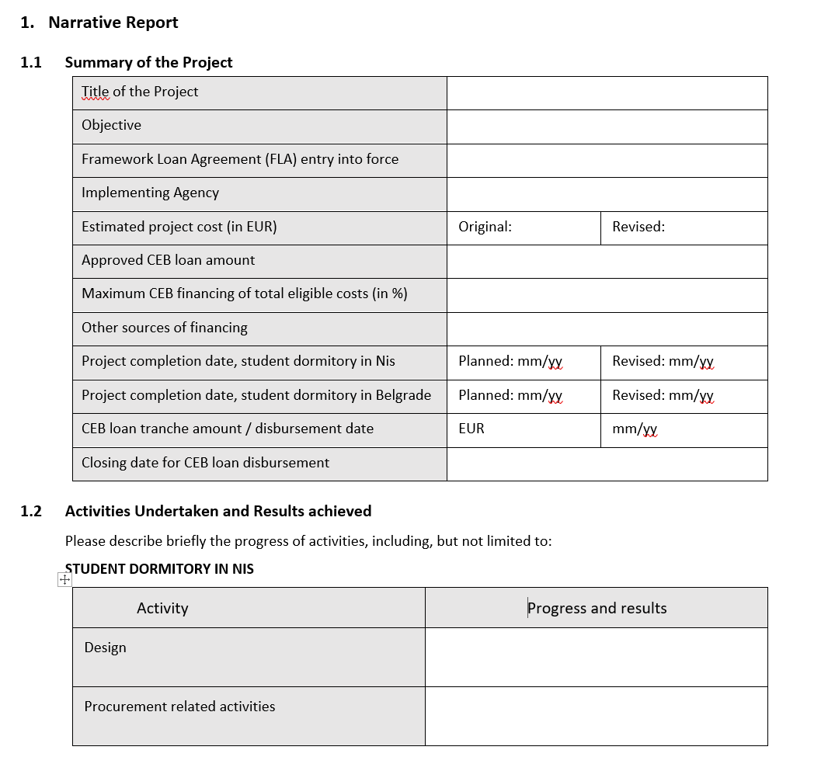

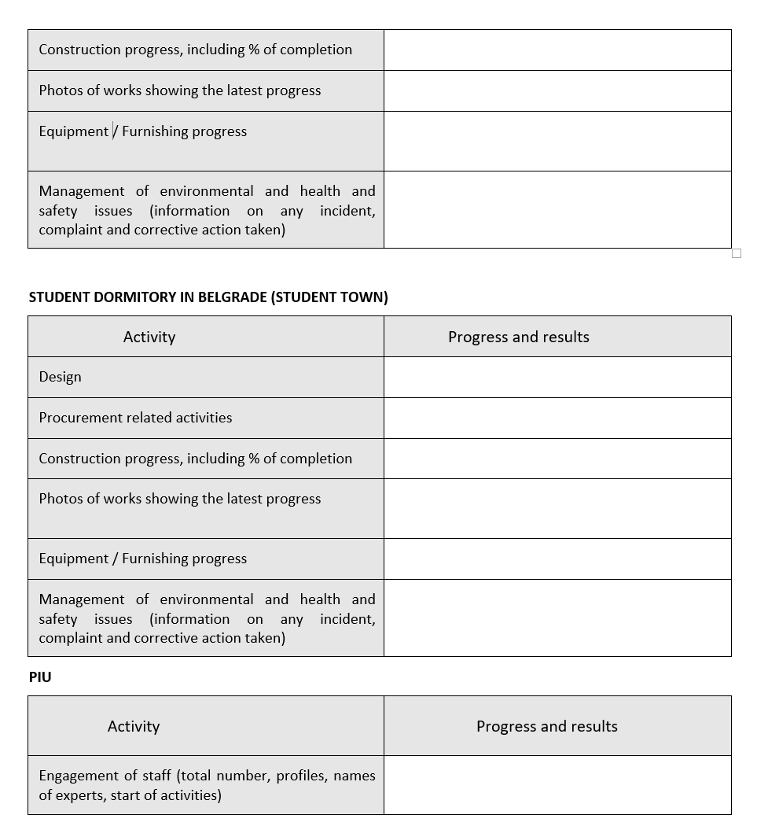

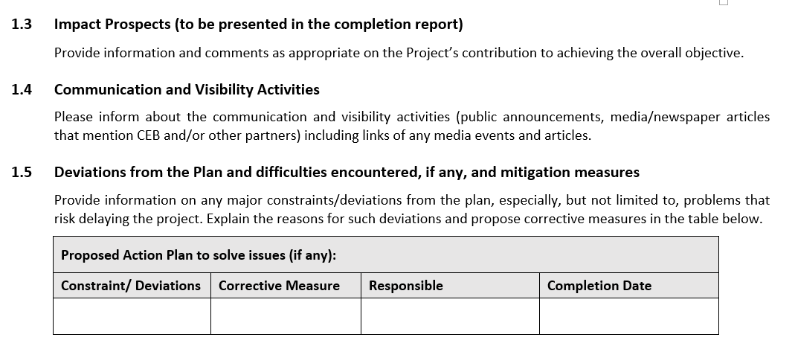

1.7 Table 2 – Indicators of achievement – (to be reported at project completion and, where possible, at design completion)
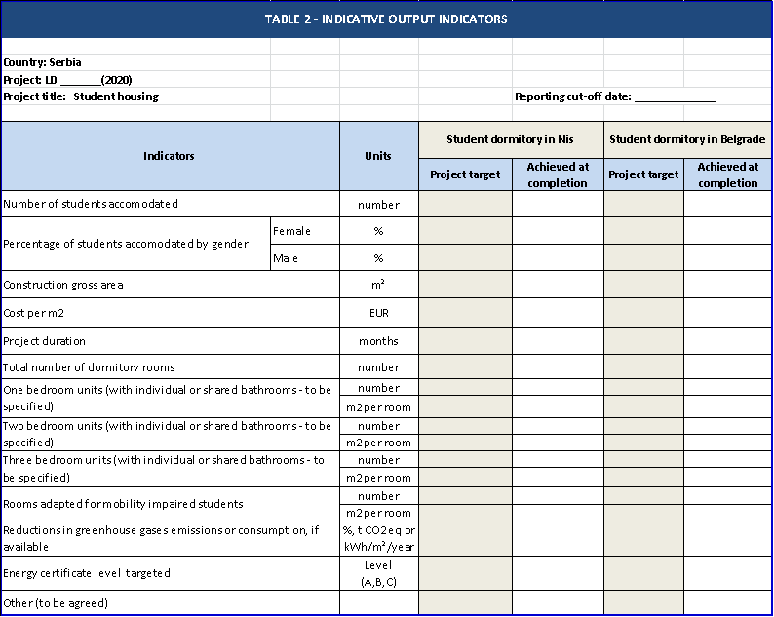



LD 2070 (2020)

OKVIRNI SPORAZUM O ZAJMU

između

BANKE ZA RAZVOJ SAVETA EVROPE

i

REPUBLIKE SRBIJE

Studentsko stanovanje
- Projektni zajam -

SADRŽAJ
1. TUMAČENjE 5
1.1 Definicije 5
1.2 Struktura 8
1.3 Naslovi 8
1.4 Zaokruživanje 8
2. USLOVI 8
3. SVRHA 8
4. FINANSIJSKI USLOVI 9
4.1 Iznos zajma 9
4.2 Iznos za isplatu 9
4.3 Postupak isplate 9
4.4 Period isplate 10
4.5 Uslovi za isplatu 10
4.6 otplata 11
4.7 prevremena otplata 11
4.8 određivanje kamate 12
4.9 Stopa zatezne kamate 12
4.10 događaj poremećaja na tržištu 12
4.11 isplate 13
5. sprovođenje projekta 14
5.1 obavezna briga 14
5.2 period alokacije 14
5.3 troškovi projekta 14
5.4 posebne obaveze po projektu 14
5.5 nabavka 15
5.6 mere zaštite u oblasti životne sredine i socijalne mere zaštite 15
5.7 ljudska prava 15
5.8 integritet 15
5.9 transparentnost 16
6. praćenje 16
6.1 izveštavanje …16
6.2 posete 17
6.3 revizija 17
6.4 informacije o projektu 17
6.5 podaci o zajmoprimcu 17
6.6 FINASIJSKE ODREDBE......................................................................................................................18
7. PARI PASSU 18
7.1 rangiranje 18
7.2 sredstvo obezbeđenja 18
7.3 kluzula koja se naknadno unosi 19
7.4 prevremena otplata trećim licima 19
8. izjave i garancije 19
9. treća lica 20
10. neodricanje 20
11. prenos 20
12. NEZAKONITOST..............................................................................................................................21
13. BEZ PRIMENE ODREDBE ZBOG PROMENE OKOLNOSTI ......................................................................21
14. merodavno pravo 21
15. sporovi 21
16. ZAŠTITA LIČNIH PODATAKA............................................................................................................21
17. obaveštenja 22
18. porezi i rashodi 23
19. isplaćivanje 23
20. stupanje na snagu 24
prilog 1 25
prilog 2 29
prilog 3 31
prilog 4 …………………………………………………………………………………………………………………………………………..............33
prillog 5.......................................................................................................................................................34

BANKA ZA RAZVOJ SAVETA EVROPE, međunarodna organizacija sa sedištem u 55, Avenue Kléber, F-75116 Pariz (Francuska) (u daljem tekstu: “BRSE” ili “Banka”), s jedne strane,
i
REPUBLIKA SRBIJA, (u daljem tekstu: “Zajmoprimac” i zajedno sa BRSE, “Strane”, a svaka pojedinačno “Strana”), s druge strane,
S OBZIROM NA TO DA
(A) Imajući u vidu da je zahtev za zajam podnet od strane Republike Srbije, kroz njeno Ministarstvo finansija, 1. oktobra 2020. godine, i odobren od Administrativnog saveta BRSE-a 13. novembra 2020. godine.
(B) Imajući u vidu Treći protokol od 6. marta 1959. godine Opšteg sporazuma o povlasticama i imunitetu Saveta Evrope od 2. septembra 1949. godine,
(C) Imajući u vidu Propise o zajmu BRSE, koji su usvojeni Rezolucijom Administrativnog saveta BRSE 1587 (2016) (u daljem tekstu: “Propisi o zajmu”),
(D) Imajući u vidu Politiku BRSE o zajmovima i finansiranju projekata, koja je usvojena Rezolucijom Administrativnog saveta BRSE 1617 (2020) (u daljem tekstu: “Kreditna politika”),
(E) Imajući u vidu Politiku o zaštiti životne sredine i merama socijalne zaštite BRSE, koja je usvojena Rezolucijom Administrativnog saveta BRSE 1588 (2016) (u daljem tekstu: „Politika o zaštiti životne sredine i merama socijalne zaštite”),
(F) Imajući u vidu Smernice o nabavkama BRSE, koje je usvojio Administrativni savet BRSE septembra 2011. godine (u daljem tekstu: “Smernice o nabavkama”),
(G) Imajući u vidu Pravilnik BRSE-a o sistemu zaštite ličnih podataka u BRSE-u, koji je usvojio Administrativni savet BRSE-a u septembru 2011. godine (u daljem tekstu: „Pravilnik o zaštiti ličnih podataka“),
(H) Imajući u vidu Povelju o antikorupciji BRSE-a, usvojenu od strane Administrativnog saveta BRSE-a u martu 2007. godine, i
(I) Imajući u vidu Politiku BRSE-a o neusaglašenim/nekooperativnim jurisdikcijama, usvojenu Rezolucijom Administrativnog saveta BRSE-a 1608 (2019),
OVIM SE DOGOVARAJU O SLEDEĆEM:

1. TUMAČENjE
1.1 Definicije
Sledeći termini će imati značenje koje je naznačeno u tekstu ispod, osim kada kontekst zahteva drugačije:
“Sporazum” označava ovaj okvirni sporazum o zajmu, uključujući i njegove priloge.
“Alokacija” označava raspoređivanje Tranše od strane Zajmoprimca na kvalifikovane sastavne delove Projekta/potprojekata čak i ako takva Tranša još nije isplaćena u skladu sa Projektom.
“Period alokacije” ima značenje definisano u potklauzuli 5.2.
“Radni dan” označava:
U odnosu na plaćanja u evrima, dan kada funkcioniše TARGET 2 (Trans European Automated Real-time Gross Settlement Express Transfer system - Transevropski automatski sistem ekspresnog transfera bruto plaćanja u realnom vremenu).
„Potvrda“ ima značenje određeno u potklauzuli 4.5 i forma je data u Prilogu 4 ovog sporazuma.
“Datum zaključenja zajma” označava datum koji je određen u Prilogu 1 ovog sporazuma posle kojeg ne može biti daljih isplata iz Zajma. Taj datum može biti promenjen nakon pisane saglasnosti obe Strane, putem razmene pisama.
“Završni izveštaj” ima značenje definisano u potklauzuli 6.1(b).
„Događaj neispunjenja obaveza“ ima značenje navedeno u potklauzuli 6.6.
“Valuta” označava, u svrhe Sporazuma, evro.
“Konvencija za utvrđivanje broja dana” označava konvenciju za utvrđivanje broja dana između dva datuma i broja dana u godini koji su naznačeni u relevantnom Obaveštenju o isplati.
“Instrument zaduživanja” označava (i) svaki zajam ili drugi oblik finansijske zaduženosti; (ii) instrument, koji uključuje priznanicu ili izvod stanja na računu, kojim se dokazuje ili predstavlja obaveza da se vrati zajam, depozit, avans ili drugo produženje kredita (uključujući bez ograničavanja produženje kredita u skladu sa sporazumom o refinansiranju ili reprogramu), (iii) obveznicu, notu, dužničke vrednosne hartije, obligacije ili slične pisane dokaze o finansijskoj zaduženosti; ili (iv) instrument kojim se dokazuje garancija o obavezi koja predstavlja finansijsku zaduženost prema drugom.
“Stopa zatezne kamate” ima značenje određeno u skladu sa potklauzulom 4.9.
“Datum isplate” označava datum na koji Tranša treba da bude isplaćena u skladu sa primenljivim Obaveštenjem o isplati.
“Obaveštenje o isplati” ima značenje definisano u potklauzuli 4.3(b).
“Zahtev za isplatu” ima značenje definisano u potklauzuli 4.3(a).
“Datum stupanja na snagu” označava datum stupanja na snagu Sporazuma kao rezultat klauzule 20.
“EU” označava Evropsku uniju.
“EURIBOR” označava procentualnu stopu koju navodi bilo koji dobavljač finansijskih vesti prihvatljiv za BRSE na ili oko 11:00 sati po vremenu u Briselu na Datum utvrđivanja kamate kao evro-finansijske stope finansiranja kojom upravlja Evropski institut za tržište novca (ili bilo koje drugo lice koje preuzima upravljanje nad tom stopom) za isti period kao relevantni Kamatni period.
Ako relevantni Kamatni period nije isti kao period koji je naveo relevantni dobavljač finansijskih vesti, primenljivi EURIBOR će biti procentualna stopa koja je rezultat linearne interpolacije upućivanjem na dve (2) EURIBOR stope, od kojih je jedna primenljiva za period celih meseci pri čemu je sledeći kraći i druga za period celih meseci pri čemu je sledeći duži nego što je dužina relevantnog Kamatnog perioda.
“Evro” i simbol “EUR” označava zakonsku valutu država članica EU koje je s vremena na vreme usvajaju kao svoju valutu u skladu sa relevantnim odredbama Ugovora o EU i Ugovora o funkcionisanju EU ili njihovim ugovorima naslednicima.
“Evropska konvencija o ljudskim pravima” označava Konvenciju o zaštiti ljudskih prava i osnovnih sloboda od 4. novembra 1950, CETS br. 5, koja se povremeno menja i dopunjava.
“Evropska socijalna povelja” označava Evropsku socijalnu povelju od 3. maja 1996, CETS br. 163, koja se povremeno menja i dopunjava.
“Krajnji korisnici” su definisani Prilogom 1 ovog sporazuma kao grupa koja ima koristi od socijalnih rezultata Projekta.
„Finansijske odredbe“ imaju značenje definisano u potklauzuli 6.6
“Fiksna kamatna stopa” označava godišnju kamatnu stopu određenu u primenljivom Obaveštenju o isplati.
“Varijabilna kamatna stopa” označava godišnju kamatnu stopu koja je utvrđena dodavanjem ili oduzimanjem Raspona određenog u primenljivom Obaveštenju o isplati, na ili od, zavisno od slučaja, Referentne kamatne stope.
Da bi se izbegla bilo kakva sumnja, kada utvrđivanje Varijabilne kamatne stope ima za rezultat negativnu kamatnu stopu (usled navedene negativne Referentne kamatne stope, na funkcionisanje Raspona koji je oduzet od Referentne kamatne stope ili zbog bilo kakvih drugih okolnosti), smatraće se da kamata koju treba da plati Zajmoprimac za Kamatni period iznosi nula.
“Prognozirani troškovi” označavaju planirane prihvatljive troškove koji će nastati u okviru Projekta u periodu od (1) godinu dana.
“Nastali troškovi” označavaju prihvatljive troškove koji su nastali radom Tela za sprovođenje projekta.
“Datum utvrđivanja kamate” označava, u svrhe utvrđivanja Varijabilne kamatne stope, dan koji pada dva (2) Radna dana pre prvog dana Kamatnog perioda, osim ako nije drugačije naznačeno u relevantnom Obaveštenju o isplati.
“Datumi plaćanja kamate” označavaju datume za plaćanje kamate koji odgovaraju relevantnom Kamatnom periodu određenom u primenljivom Obaveštenju o isplati.
“Kamatni period” označava period koji započinje na Datum plaćanja kamate i završava se na dan koji je dan pre sledećeg Datuma plaćanja kamate, pod uslovom da prvi Kamatni period primenljiv na svaku Tranšu započinje na Datum isplate i završava se na dan pre sledećeg Datuma plaćanja kamate.
“Zajam” označava zajam koji je odobren Zajmoprimcu od strane BRSE u skladu sa Sporazumom.
“Iznos zajma” označava iznos definisan u potklauzuli 4.1.
“Događaj poremećaja na tržištu” ima značenje definisano u potklauzuli 4.10.
“Materijalno negativna promena” označava svaki događaj koji, po mišljenju BRSE, (i) materijalno ugrožava sposobnost Zajmoprimca da izvršava svoje finansijske obaveze u skladu sa Sporazumom; ili (ii) na negativan način utiče na Sredstvo obezbeđenja koje je dostavio Zajmoprimac ili treće lice da bi se osiguralo blagovremeno izvršenje finansijskih obaveza Zajmoprimca u skladu sa Sporazumom; ili (iii) negativno utiče na bilo koja prava ili pravne lekove BRSE-a prema Sporazumu.
“Datum dospeća” označava poslednji Datum za otplatu glavnice za svaku Tranšu koja je određena u primenljivom Obaveštenju o isplati.
“Konvencija o modifikovanom narednom radnom danu” jeste konvencija po kojoj ukoliko određeni datum pada na dan koji nije Radni dan, taj dan će biti prvi sledeći dan koji je Radni dan, osim ako taj dan pada u narednom kalendarskom mesecu, u tom slučaju taj dan će biti prvi Radni dan koji prethodi određenom datumu.
“Potvrda o prevremenoj otplati” ima značenje definisano u potklauzuli 4.7.
“Troškovi prevremene otplate” ima značenje definisano u potklauzuli 4.7.
“Datum prevremene otplate” ima značenje definisano u potklauzuli 4.7.
“Obaveštenje o prevremenoj otplati” ima značenje definisano u potklauzuli 4.7.
“Datum(i) otplate glavnice” označava datum(e) za otplatu(e) glavnice u skladu sa svakom Tranšom utvrđenom primenljivim Obaveštenjem o isplati.
“Period za otplatu glavnice” označava u odnosu na svaku Tranšu period koji protiče od njenog Datuma isplate do njenog Datuma dospeća.
“Izveštaj o napretku” ima značenje definisano u potklauzuli 6.1(a).
“Zabranjeno delovanje” ima značenje definisano u potklauzuli 5.8(c).
“Projekat” označava kvalifikovane programe ulaganja utvrđenih u skladu sa Prilogom 1 ovog sporazuma da bi se delimično finansirali pomoću Zajma koji je odobrio Administrativni savet BRSE sa ref. LD 2070 (2020).
“Telo za sprovođenje projekta” (u daljem tekstu: “TSP”) označava pravno lice koje je, po osnovu ovlašćenja Zajmoprimca, zaduženo za sprovođenje Projekta.
„Jedinica za sprovođenje projekta“ (u daljem tekstu: „JSP“) označava tim određen od strane TSP koji je zadužen za svakodnevno upravljanje Projektom.
“Referentna kamatna stopa” označava EURIBOR za Tranšu po Varijabilnoj kamatnoj stopi koja je denominovana u evrima.
„Lista sankcija” označavaju (i) bilo koje ekonomske, finansijske i trgovinske restriktivne mere i embargoe na oružje koje je izdala EU u skladu sa poglavljem 2 odeljka V Ugovora o Evropskoj uniji, kao i članom 215 Ugovora o funkcionisanju Evropske unije, kako je dostupno na zvaničnoj veb stranici EU ili na bilo kojoj stranici koja je bude zamenila, izmenjene i dopunjene s vremena na vreme; ili (ii) bilo koje ekonomske, finansijske i trgovinske restriktivne mere i embargoe na oružje koje je izdao Savet bezbednosti Ujedinjenih nacija u skladu sa članom 41. Povelje UN-a, dostupne na zvaničnoj veb stranici UN-a ili na bilo kojoj drugoj stranici koja je bude zamenila, izmenjene i dopunjene s vremena na vreme.
„Sankcionisana lica“ označava bilo koje fizičko ili pravno lice koje je navedeno i/ili na neki drugi način se nalazi u jednoj ili više Lista sankcija.
“Sredstvo obezbeđenja” označava sporazum ili dogovor koji stvara povlašćeni položaj, pravo prečeg plaćanja, sredstvo obezbeđenja ili garanciju bilo koje vrste koje bi mogle preneti povećana prava na treća lica.
“Raspon” označava, u vezi sa Tranšom po Varijabilnoj kamatnoj stopi, fiksni raspon u odnosu na Referentnu kamatnu stopu (koja je negativna ili pozitivna) određen u baznim poenima u primenljivom Obaveštenju o isplati.
„Potprojekat“ označava kvalifikovani investicioni program koji se finansira prema Projektu, kako je definisano u Prilogu 1 ovog sporazuma.
“Tranša” predstavlja iznos koji je isplaćen ili iznos koji treba da bude isplaćen iz Zajma.
1.2 Struktura
Osim ukoliko kontekst ne zahteva drugačije, upućivanja na:
(a) ovaj sporazum tumačiće se kao upućivanja na ovaj sporazum koji može biti dopunjen, izmenjen ili prepravljen s vremena na vreme;
(b) Strana ili bilo koje drugo lice uključuje svoje naslednike u nazivu ili one dozvoljene putem prenosa;
(c) “Klauzule”, “Potklauzule” i “Uvodne izjave” tumačiće se kao upućivanja na klauzule, potklauzule i uvodne izjave pojedinačno u ovom sporazumu; i
(d) reči koje su u jednini uključivaće i množinu i obrnuto.
1.3 Naslovi
Naslovi u ovom sporazumu nemaju pravni značaj i ne utiču na njegovo tumačenje.
1.4 Zaokruživanje
U svrhe obračuna iz ovog sporazuma:
(a) svi procenti koji predstavljaju rezultat navedenih obračuna sem onih koji su utvrđeni kroz upotrebu interpolacije biće zaokruženi, po potrebi, na najbliži stohiljaditi deo procentnog poena (na primer 9,876541% (ili ,09876541) se zaokružuju na 9,87654% (ili ,0987654) i 9,876545% (ili ,09876545) se zaokružuju na 9,87655% (ili ,0987655);
(b) svi procenti utvrđeni kroz upotrebu linearne interpolacije upućivanjem na dve (2) relevantne Referentne kamatne stope biće zaokruženi, po potrebi, u skladu sa metodom utvrđenom u pododeljku (a) iznad, ali u istom stepenu tačnosti kao i dve (2) stope koje se koriste za određivanje (osim kada navedeni procenti neće biti zaokruženi na niži nivo tačnosti nego što je najbliži hiljaditi deo procentnog poena (0,001%)); i
(c) svi iznosi valuta koji se koriste ili predstavljaju rezultat gorenavedenih kalkulacija biće zaokruženi, osim ako je drugačije naznačeno u relevantnoj definiciji valute, na najbliža dva decimalna mesta relevantne valute (sa ,005 koje se zaokružuje prema gore (na primer, ,674 se zaokružuje na ,67, dok se ,675 zaokružuje na ,68).
2. USLOVI
Zajam se odobrava u skladu sa opštim uslovima Propisa o zajmu i pod posebnim uslovima Sporazuma.
3. SVRHA
BRSE odobrava Zajam Zajmoprimcu, koji ga prihvata, jedino u svrhu finansiranja Projekta kako je opisano u Prilogu 1.
Sredstva Zajma ne mogu se koristiti za plaćanje poreza (uključujući PDV), carina i drugih taksi.
Svaka promena načina na koji se Zajam koristi koja nema odobrenje BRSE predstavljala bi događaj u smislu člana 3.3 (h) Propisa o zajmu i može dovesti do prevremene otplate, obustave ili otkaza Zajma u skladu sa uslovima članova 3.3 (Prevremena otplata isplaćenih zajmova), 3.5 (Obustava neisplaćenih zajmova od strane banke) i 3.6 (Otkazivanje od strane banke isplate neisplaćenih zajmova) Propisa o zajmu.
4. FINANSIJSKI USLOVI
4.1 Iznos Zajma
Iznos Zajma je:
TRIDESET DVA MILIONA EVRA
EUR 32.000.000
4.2 Iznos za isplatu
Zajam će biti isplaćen minimalno u dve (2) Tranše.
Iznos svake Tranše, izuzev prve, biće utvrđen u skladu sa Nastalim troškovima i Prognoziranim troškovima. Iznos prve Tranše neće prekoračiti dvadeset pet procenata (25%) Iznosa zajma.
4.3 Postupak isplate
Isplata svake tranše utvrđuje se putem sledeće procedure:
(a) Zahtev za isplatu
Pre svake isplate i nakon prethodne konsultacije sa BRSE, Zajmoprimac će podneti BRSE zahtev za isplatu koji je suštinski u obliku koji je utvrđen u skladu sa Prilogom 3 ovog sporazuma (u daljem tekstu: “Zahtev za isplatu”).
Zahtev za isplatu će utvrditi sledeće:
(i) Valutu(e) i iznos(e) Tranše;
(ii) Datum isplate; navedeni datum isplate biće Radni dan koji pada barem pet (5) Radnih dana nakon datuma podnošenja Zahteva za isplatu;
(iii) Datum(e) za otplatu glavnice, uključujući Datum dospeća, uzimajući u obzir da Period za otplatu glavnice za svaku Tranšu neće prekoračiti dvadeset (20) godina uključujući period počeka koji neće biti duži od pet (5) godina;
(iv) Maksimalnu fiksnu kamatnu stopu ili maksimalan raspon u odnosu na Referentnu kamatnu stopu;
(v) Kamatni period i Datume plaćanja kamate;
(vi) Konvenciju za utvrđivanje dana i Radne dane; i
(vii) Račun Zajmoprimca za plaćanja.
Svaki Zahtev za isplatu koji je isporučen BRSE biće neopoziv, osim ako je drugačije dogovoreno u pisanom obliku od strane BRSE.
(b) Obaveštenje o isplati
Ako BRSE primi Zahtev za isplatu koji je u skladu sa uslovima Zahteva za isplatu utvrđenim u potklauzuli 4.3(a) u tekstu iznad, i ako su svi drugi relevantni Uslovi za isplatu definisani potklauzulom 4.5 (Uslovi za isplatu) u tekstu ispod ispunjeni od strane Zajmoprimca, BRSE će isporučiti Zajmoprimcu obaveštenje o isplati u obliku koji je definisan Prilogom 3 ovog sporazuma (u daljem tekstu: “Obaveštenje o isplati”). Svako Obaveštenje o isplati biće isporučeno barem dva (2) Radna dana pre predloženog Datuma isplate.
Obaveštenje o isplati će navoditi sledeće:
(i) Valutu(e) i iznos(e) Tranše;
(ii) Datum isplate;
(iii) Period za otplatu glavnice i Datum(e) za otplatu glavnice, uključujući Datum dospeća;
(iv) Fiksnu kamatnu stopu ili Raspon u odnosu na Referentnu kamatnu stopu;
(v) Kamatni period i Datume plaćanja kamate;
(vi) Konvenciju za utvrđivanje dana i Radne dane; i
(vii) Račune Zajmoprimca i BRSE-a za plaćanja.
Obaveštenje o isplati koje se podudara sa elementima Zahteva za isplatu predstavljaće neopozivu i bezuslovnu rešenost Zajmoprimca da uzme pozajmicu od BRSE-a i sa strane BRSE-a da isplati Tranšu Zajmoprimcu u skladu sa uslovima određenim u Obaveštenju o isplati.
Bez obzira na gore navedeno, ako BRSE nije isporučila Obaveštenje o isplati u roku od deset (10) Radnih dana nakon prijema Zahteva za isplatu, smatraće se da je relevantni Zahtev za isplatu otkazan.
4.4 Period isplate
Osim ako je BRSE drugačije dogovorio u pisanom obliku, Zajmoprimac neće imati pravo na:
(i) podnošenje Zahteva za isplatu prve Tranše posle dvanaest (12) meseci nakon što Strane potpišu Sporazum;
(ii) podnošenje bilo kakvog dodatnog Zahteva za isplatu nakon osamnaest (18) meseci od poslednje isplate; ili
(iii) podnošenje bilo kakvog dodatnog Zahteva za isplatu nakon dana koji pada petnaest (15) Radnih dana pre Datuma zaključenja zajma.
4.5 Uslovi za isplatu
(a) Uslovi koji prethode Zahtevu za isplatu prve Tranše:
(i) Pravno mišljenje na engleskom jeziku koje izdaje Ministarstvo pravde Zajmoprimca koje potvrđuje na zadovoljavajući način za BRSE, suštinski u obliku koji je utvrđen u Prilogu 2 ovog sporazuma, da je Sporazum uredno potpisan od strane ovlašćenih predstavnika Zajmoprimca i da je Sporazum važeći, obavezujući i izvršiv u skladu sa njegovima uslovima u jurisdikciji koja je važeća za Zajmoprimca.
(ii) Dokaz na engleskom jeziku (na primer, punomoćje, itd.) na zadovoljavajući način za BRSE o licu (licima) koja su ovlašćena da potpišu Sporazum i Zahteve za isplatu u ime Zajmoprimca, zajedno sa overenim kartonom deponovanih potpisa takvog (takvih) lica;
(iii) Potvrda od Zajmoprimca u formi datoj u Prilogu 4 ovog sporazuma, potpisanoj od strane lica ovlašćenih da potpisuju Zahteve za isplatu u ime Zajmoprimca i datirana na datum koji pada ne ranije od pet (5) Radnih dana pre Zahteva za isplatu.
(iv) Bilo koji drugi uslov primenljiv na Zajam/Projekat.
(b) Uslovi koji prethode svakom sledećem Zahtevu za isplatu:
(i) Dokaz na engleskom jeziku (na primer, punomoćje, itd.) na zadovoljavajući način za BRSE o licu (licima) koja su ovlašćena da potpišu Sporazum i Zahteve za isplatu u ime Zajmoprimca, zajedno sa overenim kartonom deponovanih potpisa takvog (takvih) lica.
(ii) Izveštaj o napretku kojim se potvrđuje, na zadovoljavajući način za BRSE, potpuna Alokacija prethodne Tranše;
(iii) Potvrda od Zajmoprimca u formi datoj u Prilogu 4 ovog sporazuma, potpisanoj od strane lica ovlašćenih da potpisuju Zahteve za isplatu u ime Zajmoprimca i datirana na datum koji pada ne ranije od pet (5) Radnih dana pre Zahteva za isplatu.
4.6 Otplata
Na svaki Datum otplate glavnice, Zajmoprimac će otplatiti glavnicu svake Tranše koja je dospela za plaćanje na taj Datum otplate glavnice u skladu sa uslovima utvrđenim u primenljivom Obaveštenju o isplati.
  - Prevremena otplata
(a) Mehanizam
Ako u bilo kom slučaju navedenom u ovom sporazumu, a odnosi se na ovu potklauzulu, Zajmoprimac treba da izvrši prevremenu otplatu cele ili dela Tranše ili u slučaju dobrovoljne prevremene otplate, Zajmoprimac će uputiti pisano obaveštenje BRSE-u barem dva (2) meseca pre (u daljem tekstu: “Obaveštenje o prevremenoj otplati”), navodeći iznose koji treba da se prevremeno otplate, datum na koji će prevremena otplata biti izvršena (u daljem tekstu: “Datum prevremene otplate”) i, po prethodnoj konsultaciji sa BRSE, Troškove prevremene otplate. Datum prevremene otplate pašće na Datum plaćanja kamate, osim ako je BRSE drugačije dogovorio pisanim putem.
Nakon prijema Obaveštenja o prevremenoj otplati, BRSE će poslati pisano obaveštenje Zajmoprimcu (u daljem tekstu: “Potvrda o prevremenoj otplati”), najkasnije petnaest (15) Radnih dana pre Datuma prevremene otplate, ukazujući na obračunatu kamatu i na Troškove prevremene otplate u skladu sa potklauzulom 4.7 (b).
Potvrda o prevremenoj otplati koja se podudara sa elementima Obaveštenja o prevremenoj otplati predstavljaće neopozivu i bezuslovnu rešenost Zajmoprimca da prevremeno otplati BRSE-u relevantne iznose u skladu sa uslovima određenim u Potvrdi o prevremenoj otplati. Ukoliko BRSE nije isporučio Potvrdu o prevremenoj otplati u okviru roka koji je naveden u tekstu iznad, smatraće se da je Obaveštenje o prevremenoj otplati otkazano.
Ako Zajmoprimac delimično prevremeno otplati Tranšu, iznos prevremene otplate će se primenjivati proporcionalno na svaku neizmirenu otplatu glavnice. U tom slučaju, Potvrda o prevremenoj otplati će u skladu sa tim da uključi i prilagođeni otplatni plan koji će biti obavezujući po Zajmoprimca.
(b) Troškovi prevremene otplate
Troškove koji su rezultat prevremene otplate u skladu sa potklauzulom 4.7 (a) (u daljem tekstu: “Troškovi prevremene otplate”) utvrdiće BRSE na osnovu troškova koje je snosila preraspoređivanjem iznosa koji treba da se prevremeno otplati od Datuma prevremene otplate do Datuma dospeća, uključujući sve srodne troškove, kao što su i troškovi po osnovu hedžing aranžmana. Troškovi preraspoređivanja će biti ustanovljeni na osnovu razlike između prvobitne stope i stope preraspoređivanja, što će utvrditi BRSE na osnovu uslova na tržištu na datum izdavanja Obaveštenja o prevremenoj otplati.
4.8 Određivanje kamate
Zajmoprimac će platiti kamatu na glavnicu svake Tranše povremeno neizmirenoj tokom svakog Kamatnog perioda po Fiksnoj kamatnoj stopi/Varijabilnoj kamatnoj stopi utvrđenoj u primenljivom Obaveštenju o isplati.
Kamata će se (i) obračunavati od i uključujući prvi dan Kamatnog perioda do, ali isključujući poslednji dan navedenog kamatnog perioda; i (ii) dospeće za naplatu i biće naplativa na Datume plaćanja kamate određene u primenljivom Obaveštenju o isplati. Kamata će se obračunavati na osnovu Konvencije za utvrđivanje broja dana utvrđene u relevantnom Obaveštenju o isplati.
U slučaju Tranši sa Varijabilnom kamatnom stopom, BRSE će utvrđivati na svaki Datum utvrđivanja kamate, kamatnu stopu koja je primenljiva tokom relevantnog Kamatnog perioda u skladu sa Sporazumom i odmah će o tome obavestiti Zajmoprimca. Svako utvrđivanje od strane BRSE biće konačno, zaključno i obavezujuće po Zajmoprimca osim ako Zajmoprimac dokaže, na zadovoljavajući način za BRSE, da to utvrđivanje sadrži očiglednu grešku.

4.9 Stopa zatezne kamate
U slučaju da Zajmoprimac ne uspe da plati u potpunosti ili delimično, bilo koji iznos u skladu sa Sporazumom, i uprkos bilo kojoj drugoj naknadi raspoloživoj za BRSE u skladu sa Sporazumom ili inače, Zajmoprimac će platiti kamatu na navedene neplaćene iznose od datuma dospeća do datuma prijema navedene uplate od strane BRSE po godišnjoj kamatnoj stopi jednakoj jednomesečnom EURIBOR-u kotiranom na datum dospeća plus dvesta baznih poena (200 baznih poena) (u daljem tekstu: “Stopa zatezne kamate”).
Primenljiva Stopa zatezne kamate se ažurira svakih trideset (30) kalendarskih dana.
4.10 Događaj poremećaja na tržištu
BRSE će odmah po saznanju obavestiti Zajmoprimca da je došlo do Događaja poremećaja na tržištu.
U svrhe Sporazuma, “Događaj poremećaja na tržištu” odnosi se na sledeće okolnosti:
(a) Relevantni dobavljač finansijskih vesti pod definicijom EURIBOR nije naveo bilo koju procentualnu stopu ili njegova odgovarajuća strana sa objavljenom stopom nije dostupna.
U takvom Događaju poremećaja na tržištu, primenljivi EURIBOR predstavljaće procentualnu godišnju kamatnu stopu koju je utvrdila BRSE kao aritmetičku sredinu stopa pri kojima se zajmovi u evrima, u iznosu koji je identičan ili najbliže uporediv sa iznosom predmetnog zajma i za period koji je identičan ili najbliže uporediv sa relativnim Kamatnim periodom, nude na Datum utvrđivanja kamate tri (3) vodeće banke na međubankarskom tržištu EU koje je odabrala BRSE. Ako postoje barem dva (2) kotiranja, primenljivi EURIBOR za taj Datum utvrđivanja kamate predstavljaće aritmetičku sredinu datih kotiranja.
Ako je ponuđeno samo jedno (1) kotiranje ili nijedno, primenljivi EURIBOR će biti procentualna godišnja kamatna stopa koju je utvrdila BRSE kao aritmetičku sredinu stopa pri kojima se zajmovi u evrima, u iznosu koji je identičan ili najbliže uporediv sa iznosom predmetnog zajma i za period koji je identičan ili najbliže uporediv sa povezanim Kamatnim periodom, dat na drugi Radni dan nakon početka relevantnog Kamatnog perioda od strane vodećih banaka na međubankarskom tržištu EU koje je odabrala BRSE.
(b) BRSE odlučuje da nije moguće da se utvrdi primenljiva Referentna kamatna stopa u skladu sa stavom (a) u tekstu iznad.
Tokom takvog Događaja poremećaja na tržištu, primenljiva Varijabilna kamatna stopa će biti zamenjena stopom koja izražava kao procentualnu godišnju kamatnu stopu trošak BRSE za finansiranje Zajma, bez obzira na to koji izvor BRSE može opravdano odabrati.
(c) U svakom trenutku između isporuke Obaveštenja o isplati i Datuma isplate, BRSE opravdano utvrđuje da li postoje izuzetne i neočekivane okolnosti ekonomske, finansijske, političke ili druge spoljne prirode koje na negativan način utiču na pristup BRSE svojim izvorima finansiranja.
Tokom takvog Događaja poremećaja na tržištu, BRSE će imati pravo da otkaže bez naplate bilo kakvih troškova predviđenu isplatu.
U slučaju Događaja poremećaja na tržištu utvrđenih pod stavkama (a) i (b) u tekstu iznad:
(i) Ako Zajmoprimac to zahteva, Strane, delujući u dobroj veri, stupaju u pregovore u periodu ne dužem od trideset (30) kalendarskih dana da bi se dogovorile o alternativi za primenljivi EURIBOR. Ako ne dođe do dogovora, Zajmoprimac može da nastavi sa prevremenom otplatom na sledeći Datum isplate kamate pod uslovima definisanim u potklauzuli 4.7.
(ii) BRSE ima pravo, delujući u dobroj veri i konsultujući se sa Zajmoprimcem u meri koja je razumno izvodljiva, da promeni trajanje sledećeg Kamatnog perioda na trideset (30) kalendarskih dana ili manje, tako što će Zajmoprimcu da pošalje obaveštenje o tome. Svaka takva promena Kamatnog perioda će postati važeća na datum koji je definisala BRSE u navedenom obaveštenju.
(iii) Da bi se izbegla bilo kakva sumnja, stavke (i) i (ii) iznad će se odnositi samo na okolnosti kada Zajmoprimac plaća kamatu na glavnicu neotplaćene Tranše po Varijabilnoj kamatnoj stopi.
Ako BRSE utvrdi da relevantni Događaj poremećaja na tržištu više ne postoji, onda, zavisno od bilo kog sledećeg Događaja poremećaja na tržištu do koga dođe ili koji postoji, Varijabilna kamatna stopa i/ili Kamatni period koji su primenljivi na relevantnu Tranšu će se vratiti na staro, od prvog dana sledećeg Kamatnog perioda do obračuna u skladu sa Varijabilnom kamatnom stopom i Kamatnog perioda utvrđenog u relevantnom Obaveštenju o isplati.
4.11 Isplate
Svi iznosi koje Zajmoprimac treba da isplati u skladu sa ovim sporazumom su naplativi u Valuti pojedinačne Tranše na račun BRSE koji je naznačen u primenljivom Obaveštenju o isplati. Svako plaćanje u skladu sa ovim sporazumom vršiće se na Radni dan koji podleže Konvenciji o modifikovanom narednom radnom danu. Smatraće se da su isplate izvršene kada BRSE primi iznos na svoj račun.
Zajmoprimac ili Banka po instrukciji Zajmoprimca, zavisno od slučaja, šalje pisano obaveštenje o plaćanju BRSE-u najmanje pet (5) Radnih dana pre plaćanja bilo kog iznosa koji dospeva na naplatu u skladu sa ovim sporazumom.
Sve isplate koje će Zajmoprimac izvršiti prema ovom sporazumu će se izračunavati i izvršiti bez (i oslobođene od bilo kakvog odbitka za) poravnanja ili protivtužbe.
Ako BRSE primi uplatu koja je nedovoljna za isplatu svih dospelih i naplativih iznosa od strane Zajmoprimca prema ovom sporazumu, BRSE će primeniti tu uplatu na ili prema plaćanju:
(i) prvo, bilo kojih naknada, troškova, taksi ili izdataka dospelih, ali neplaćenih po ovom sporazumu;
(ii) drugo, bilo koja obračunata kamata, dospela, ali neplaćena po ovom sporazumu,
(iii) treće, bilo koja glavnica dospela, ali neplaćena po ovom sporazumu; i
(iv) četvrto, bilo koji drugi iznos dospeo, ali neplaćen po ovom sporazumu.

5. SPROVOĐENjE PROJEKTA
Zajmoprimac će sprovesti Projekat u skladu sa Sporazumom.
Zajmoprimac određuje Ministarstvo prosvete, nauke i tehnološkog razvoja kao TSP. Zajmoprimac će obezbediti da TSP imenuje JSP adekvatno opremljenu osobljem i opremom tokom celokupnog trajanja perioda sprovođenja Projekta, na zadovoljavajući način za BRSE.
U svakom slučaju, Zajmoprimac ostaje jedini odgovoran za usklađivanje sa obavezama u skladu sa Sporazumom.
Neuspeh da se ispoštuju obaveze utvrđene ovim sporazumom u skladu sa klauzulom 5 predstavljao bi, bez obzira na bilo koju drugu primenljivu odredbu Propisa o zajmu, događaj u smislu člana 3.3 (h) Propisa o zajmu i može dovesti do (i) relevantnog troška potprojekta proglašenog neprihvatljivim za Alokaciju prema Projektu; i/ili (ii) do prevremene otplate, obustave ili otkaza Zajma, u celosti ili delimično, u skladu sa uslovima članova 3.3 (Prevremena otplata isplaćenih zajmova), 3.5 (Obustava neisplaćenih zajmova od strane Banke) i 3.6 (Otkazivanje od strane Banke isplate neisplaćenih zajmova) Propisa o zajmu.
5.1 Obavezna briga
Zajmoprimac će pokazati maksimalnu brigu i pažnju, i primeniće sva uobičajeno korišćena sredstva (uključujući, ali se ne ograničavajući na pravna, finansijska, upravljačka i tehnička) potrebna za valjano sprovođenje Projekta.
5.2 Period alokacije
Zajmoprimac će alocirati svaku Tranšu za Projekat u okviru dvanaest (12) meseci od relevantnog Datuma isplate (“Period alokacije”), osim ukoliko se drugačije ne dogovore Zajmoprimac i BRSE.
Ako Tranša koju je isplatila BRSE nije dodeljena Projektu ili mu je dodeljena delimično tokom Perioda alokacije, Zajmoprimac će izvršiti prevremenu otplatu nealociranih iznosa na sledeći Datum plaćanja kamate u skladu sa uslovima u potkaluzuli 4.7, osim ukoliko se drugačije ne dogovore Zajmoprimac i BRSE.
5.3 Troškovi Projekta
Tranše isplaćene u vezi sa Zajmom neće prekoračiti šezdeset šest procenata (66%) ukupnih kvalifikovanih troškova Projekta određenih u Prilogu 1 ovog sporazuma. Ako Tranše isplaćene u vezi sa Zajmom prekorače gore pomenutih 66% (umanjenjem ukupnih kvalifikovanih troškova ili na drugi način), Zajmoprimac će izvršiti prevremenu otplatu viška na sledeći Datum plaćanja kamate u skladu sa uslovima u potklauzuli 4.7.
Ukoliko se ukupni kvalifikovani troškovi Projekta povećaju ili se revidiraju iz bilo kog razloga, Zajmoprimac će omogućiti da dodatna finansijska sredstva za okončanje Projekta budu raspoloživa bez obraćanja BRSE-u. Planovi da se povećani troškovi finansiraju biće saopšteni BRSE-u bez odlaganja.
5.4 Posebne obaveze po Projektu
Zajmoprimac će se postarati da:
(i) celokupno zemljište, imovinska prava, kao i sve dozvole potrebne za sprovođenje Projekta budu blagovremeno obezbeđene; i
(ii) sva imovina i postrojenja koji predstavljaju deo ovog Projekta moraju biti trajno osigurani i održavani u skladu sa najboljom međunarodnom praksom.
(iii) bilo koji drugi uslov definisan u Prilogu 1 („Posebni usloviˮ) ovog sporazuma bude ispunjen.
5.5 Nabavka
Nabavka radova, roba i usluga koji treba da se finansiraju u skladu sa Projektom biće usaglašena sa BRSE-ovim Smernicama o nabavci.
5.6 Mere zaštite u oblasti životne sredine i socijalne mere zaštite
Zajmoprimac će putem TSP sprovoditi Projekat u skladu sa zahtevima utvrđenim u Politici o zaštiti životne sredine i merama socijalne zaštite. Posebno, ukoliko Projekat zahteva Procenu uticaja na životnu sredinu (Environmental Impact Assesment - EIA) ili Ekološku i socijalnu procenu uticaja (Environmental and Social Impact Assessment - ESIA) u skladu sa Politikom o zaštiti životne sredine i merama socijalne zaštite, Zajmoprimac će obavestiti BRSE i obezbediti da se odgovarajuće EIA/ESIA preduzmu u skladu zahtevima Politike o zaštiti životne sredine i merama socijalne zaštite. Zajmoprimac će obezbediti da odgovarajuća dokumentacija u vezi sa EIA/ESIA bude dostupna BRSE-u na zahtev.
5.7 Ljudska prava
Zajmoprimac će putem TSP i JSP obezbediti da sprovođenje Projekta ne dovede do kršenja (i) Evropske konvencije o ljudskim pravima; ili (ii) Evropske socijalne povelje.
5.8 Integritet
Zajmoprimac, direktno ili kroz TSP i JSP preduzima da:
(a) će uspostaviti i nakon toga se pridržavati unutrašnjih politika, postupaka i kontrola, u skladu sa važećim zakonodavstvom i najboljom međunarodnom praksom, u svrhu sprečavanja da Zajmoprimac postane, u vezi sa sprovođenjem Projekta ili na drugi način, instrument za pranje novca ili finansiranje terorizma;
(b) ne učini dostupnim sredstva Zajma za ili u korist bilo koje sankcionisane osobe, direktno ili indirektno;
(c) se neće obavezati i da nijedno lice, uz njegovu saglasnost ili prethodno znanje, neće počiniti, u vezi sa sprovođenjem Projekta, Podmićivanje, Obmanjivanje, Prinudu, Tajno dogovaranje ili Opstrukciju (u daljem tekstu, zajedno sa pranjem novca, finansiranjem terorizma i stavljanjem na raspolaganje sredstava Zajma Sankcionisanim licima koji se naziva: „Zabranjena delovanja“).
U smislu ovog sporazuma:
(i) „Podmićivanje“ predstavlja nuđenje, davanje, primanje ili traženje, bilo direktno ili indirektno, neke vrednosti radi neodgovarajućeg uticaja na postupanje neke druge strane.
(ii) „Obmanjivanje“ predstavlja svako činjenje ili nečinjenje, uključujući pogrešne tvrdnje, kojima se svesno ili nesvesno vrši obmana, ili se čini pokušaj obmanjivanja jedne strane da bi se stekla neka finansijska ili druga korist ili izbegla neka obaveza.
(iii) „Prinuda“ je ugrožavanje ili nanošenje štete ili pretnja ugrožavanjem ili nanošenjem štete, direktno ili indirektno, nekoj strani ili imovini te strane u cilju neprikladnog uticaja na njeno postupanje.
(iv) „Tajno dogovaranje“ je dogovor između dve ili više strana sa ciljem da se ostvari neki neprikladan cilj, uključujući neprikladno uticanje na postupanje druge strane.
(v) „Opstrukcija“ znači, u vezi sa istragom Prinude, Tajnoj dogovaranja, Podmićivanja ili Obmanjivanja, (a) svako delo namernog uništavanja, falsifikovanja, promene ili prikrivanja dokaznog materijala u istrazi; (b) bilo koji čin pretnje, uznemiravanja ili zastrašivanja bilo koje strane kako bi se sprečilo da obelodani svoje znanje o pitanjima relevantnim za istragu ili da nastavi istragu; i/ili (c) bilo koji akt kojim se namerava materijalno ometanje vršenja ugovornih prava revizije ili pristupa informacijama.
Zajmoprimac se, direktno ili kroz TSP i JSP, obavezuje da obavesti BRSE ako sazna za bilo koju činjenicu ili informaciju koje ukazuju na to da je počinjeno neko od ovih Zabranjenih delovanja. U tu svrhu, saznanje nekog člana TSP i JSP, smatraće se saznanjem Zajmoprimca.
Zajmoprimac se, direktno ili kroz TSP i JSP obavezuje:
(i) da na vreme preduzme one mere koje BRSE bude opravdano zahtevala da istraži i/ili prekine svaki navodni ili sumnjivi čin Zabranjenog delovanja;
(ii) da omogući svaku istragu koju može da vrši BRSE u vezi sa navodnim ili stvarnim Zabranjenim delovanjem; i
(iii) da obavesti BRSE o merama koje su preduzete da se zatraži odšteta od lica koja su odgovorna za bilo koji gubitak koji proističe iz takvog čina Zabranjenog delovanja.
Direktor JSP će biti odgovoran za kontakte sa BRSE u svrhu ove potklauzule.
5.9 Transparentnost
Zajmoprimac će obavestiti Krajnje korisnike putem odgovarajućih sredstava komunikacije da je Projekat delimično finansiran sredstvima BRSE namenskim obaveštenjima na vebsajtovima, društvenim mrežama, izjavama za štampu, brošurama odnosno bilbordima/tablama na odgovarajućim lokacijama/postrojenjima Projekta. U svakom slučaju, informacije date Krajnjim korisnicima prikazivaće BRSE-ov naziv i logo na prikladan način.
6. PRAĆENjE
  - Izveštavanje
(a) Izveštaj o napretku
Zajmoprimac će kroz JSP slati BRSE izveštaj o napretku (u daljem tekstu: “Izveštaj o napretku”) (i) jednom godišnje, do završetka Projekta; i (ii) pre svakog Zahteva za isplatu, izuzev kod Zahteva za isplatu prve Tranše.
U Prilogu 5 ovog sporazuma, nalazi se primer kojim se utvrđuju minimalne informacije potrebne BRSE. Alternativni formati koji sadrže istu vrstu informacija se takođe mogu koristiti.
(b) Završni izveštaj
Nakon završetka Projekta, Zajmoprimac će kroz JSP predati izveštaj o završetku (u daljem tekstu: “Završni izveštaj”) koji sadrži ocenu socijalnih efekata Projekta.
Prilog 5 ovog sporazuma sadrži primer kojim se utvrđuju minimalni podaci koje BRSE zahteva. Alternativni formati koji sadrže iste podatke se takođe mogu koristiti.
6.2 Posete
Zajmoprimac se, direktno ili kroz TSP i JSP, obavezuje da prihvati posete praćenja/tehničke posete/procenjivanja, uključujući olakšavanje pristupa relevantnim lokacijama Projekta/izvođačima, koje vrše zaposleni BRSE ili imenovana treća lica.
6.3 Revizija
Ako se Zajmoprimac ne usaglasi sa bilo kojom od obaveza u skladu sa Sporazumom, Zajmoprimac se obavezuje da prihvati reviziju na lokaciji, koju vrše zaposleni BRSE ili imenovana treća lica, što će biti na teret Zajmoprimca.
6.4 Informacije o Projektu
Zajmoprimac će voditi računovodstvenu evidenciju za Projekat u skladu sa međunarodnim standardima, iz koje će se u svakom trenutku videti stanje napredovanja Projekta, i koja će evidentirati sve obavljene poslove, i utvrditi sredstva i usluge koji se delimično finansiraju iz Zajma.
Zajmoprimac će kroz JSP isporučiti BRSE blagovremeno sve podatke ili dokumenta koja se tiču finansiranja ili sprovođenja (uključujući posebno socijalna pitanja, pitanja zaštite životne sredine i nabavki) Projekta što BRSE može opravdano zahtevati.
Zajmoprimac će odmah kroz JSP obavestiti BRSE o bilo kojem događaju koji bi mogao da ima uticaj na sprovođenje Projekta, uključujući, ali se ne ograničavajući na:
(i) svaki postupak ili protest koji je započet ili prigovor koji je podignut od strane trećeg lica ili bilo koja žalba koju je primio Zajmoprimac ili sudski spor koji je započet ili se njime preti u pogledu nabavke, socijalnih ili pitanja zaštite životne sredine ili drugih pitanja koja utiču na Projekat; ili
(ii) svako donošenje zakona ili izmene i dopune zakona, propisa ili pravila (ili u primeni ili zvaničnom tumačenju bilo kog zakona, propisa ili pravila) u vezi sa Projektom.
Svaki događaj koji može imati materijalno negativni uticaj po sprovođenje Projekta bi predstavljao događaj u smislu člana 3.3 (h) Propisa o zajmu i može dovesti do prevremene otplate, obustave ili otkaza zajma u skladu sa uslovima članova 3.3 (Prevremena otplata isplaćenih zajmova), 3.5 (Obustava neisplaćenih zajmova od strane Banke) i 3.6 (Otkazivanje od strane Banke isplate neisplaćenih zajmova) Propisa o zajmu.
6.5 Podaci o Zajmoprimcu
Zajmoprimac će, direktno ili kroz TSP, u obliku i sadržaju koji su zadovoljavajući za BRSE, svake godine dostavljati sažetak godišnjeg budžeta Zajmoprimca i srodne informacije o izvršenju budžeta i o njegovom opštem finansijskom stanju, koje BRSE s vremena na vreme može razumno zahtevati, osim ukoliko je objavljeno na zvaničnoj internet stranici Ministarstva finansija ili Narodne banke Srbije, i dostupno na engleskom jeziku.
Zajmoprimac će, direktno ili kroz TSP i JSP, obavestiti BRSE o svakoj materijalno negativnoj promeni odmah nakon što postane svestan da se ona desila. Svaka materijalno negativna promena bi predstavljala događaj u smislu člana 3.3 (h) Propisa o zajmu i može dovesti do prevremene otpate, obustave ili otkaza zajma u skladu sa uslovima članova 3.3 (Prevremena otplata isplaćenih zajmova), 3.5 (Obustava neisplaćenih zajmova od strane Banke) i 3.6 (Otkazivanje od strane Banke isplate neisplaćenih zajmova) Propisa o zajmu.
6.6 Finansijske odredbe
Zajmoprimac će obavestiti BRSE ukoliko se desi bilo koji Događaj neispunjenja obaveza. Bilo koji Događaj neispunjenja obaveza će predstavljati događaj u smislu člana 3.3 (h) Propisa o zajmu i može dovesti do obustave, otkaza ili prevremene otplate Zajma u skladu sa uslovima članova 3.3 (Prevremena otplata isplaćenih zajmova), 3.5 (Obustava neisplaćenih zajmova od strane Banke) i 3.6 (Otkazivanje od strane Banke isplate neisplaćenih zajmova) Propisa o zajmu.
U smislu ovog sporazuma, „Događaj neispunjenja obaveza“ označava situaciju u kojoj se, nakon bilo kog neizvršenja obaveza, od Zajmoprimca zahteva ili je moguće zahtevati ili će se, nakon isteka primenljivog ugovornog perioda počeka, zahtevati ili biti u mogućnosti da se zahteva da prevremeno otplati, otplati ili raskine pre dospeća svaki Instrument zaduživanja ili je bilo koja obaveza koja je u vezi sa Instrumentom zaduživanja raskinuta ili obustavljena.
7. PARI PASSU
Neuspeh usaglašavanja sa odredbama navedenim pod klauzulom 7 predstavljao bi događaj u smislu člana 3.3 (h) Propisa o zajmu i može dovesti do prevremene otplate, obustave ili otkaza Zajma u skladu sa uslovima iz članova 3.3 (Prevremena otplata isplaćenih zajmova), 3.5 (Obustava neisplaćenih zajmova od strane Banke) i 3.6 (Otkazivanje od strane Banke isplate neisplaćenih zajmova) Propisa o zajmu.
7.1 Rangiranje
Zajmoprimac će obezbediti da njegove obaveze plaćanja u skladu sa ovim sporazumom jesu i biće najmanje u rangu pari passu u pravu plaćanja sa svim drugim tekućim i budućim neobezbeđenim i nepodređenim obavezama prema njegovim Instrumentima zaduživanja.
Posebno, Zajmoprimac neće izvršiti (ili odobriti) bilo koje plaćanje u vezi sa bilo kojim takvim Instrumentom zaduživanja (bez obzira da li se redovno zakazuje ili ne) ako:
(i) BRSE zatraži prevremenu otplatu u skladu sa članom 3.3 (Prevremena otplata isplaćenih zajmova) Propisa o zajmu; ili
(ii) je došlo do ili se nastavlja događaj ili potencijalni događaj neizvršenja obaveza u pogledu neobezbeđenih i podređenih Instrumenata zaduženja Zajmoprimca ili neke od njegovih agencija ili državnih organa.
Međutim, isplata u pogledu takvog Instrumenta zaduženja je moguća ako Zajmoprimac:
(i) plaća istovremeno; ili
(ii) odvaja sa strane na namenski račun za plaćanje na sledeći Datum plaćanja kamate
sumu koja ja jednaka istom odnosu neizmirene glavnice u skladu sa ovim sporazumom kao što je odnos koji plaćanje pod takvim Instrumentom zaduživanja nosi prema ukupnom neizmirenom dugu prema tom instrumentu.
U tu svrhu, bilo koje plaćanje Instrumenta zaduživanja koje se vrši iz sredstava dobijenih emitovanjem drugog instrumenta, na koja su se prevashodno pretplatila ista lica koja imaju potraživanja po Instrumentu zaduživanja, se zanemaruje.
7.2 Sredstvo obezbeđenja
Ukoliko se odobri Sredstvo obezbeđenja za izvršenje bilo kog Instrumenta zaduživanja Zajmoprimca, Zajmoprimac će blagovremeno obavestiti BRSE o svojim namerama, i ako to BRSE zahteva, dostaviće BRSE u okviru roka koji je definisan u obaveštenju BRSE, identično ili ekvivalentno Sredstvo obezbeđenja za izvršenje svojih finansijskih obaveza u skladu sa ovim sporazumom.
Ova odredba se neće primenjivati na Sredstvo obezbeđenja:
(a) nastalo na svojini u trenutku kupovine jedino kao zalog za plaćanje kupoprodajne cene ili za otplatu duga nastalog u svrhu finansiranja kupovine navedene svojine;
(b) koje obezbeđuje Instrument zaduživanja čije dospeće pada ne duže od godinu dana nakon datuma na koji je prvobitno nastao;
(c) koje je BRSE prethodno odobrila.
7.3 Klauzula koja se naknadno unosi
Ako bilo koji od Instrumenata zaduživanja Zajmoprimca uključuje klauzule o gubitku rejtinga, finansijskim pokazateljima ili pari passu odredbama koje nisu sastavni deo Sporazuma ili su strože od bilo koje ekvivalentne odredbe ovog sporazuma, Zajmoprimac o tome obaveštava BRSE i, na njen zahtev u formi pisanog obaveštenja, u roku navedenom u BRSE obaveštenju, izvršava izmenu i dopunu ovog sporazuma kako bi obezbedio ekvivalentnu odredbu u korist BRSE.
7.4 Prevremena otplata trećim licima
Ako Zajmoprimac dobrovoljno prevremeno otplati (radi izbegavanja sumnje, prevremena otplata uključuje ponovni otkup tamo gde je to primenljivo), u celosti ili delimično, bilo koji Instrument zaduživanja, i takva prevremena otplata:
(a) nije izvršena u okviru revolving kredita koji ostaje otvoren za povlačenje pod istim uslovima nakon takve prevremene otplate; ili
(b) nije učinjena sredstvima drugog Instrumenta zaduživanja čiji je rok najmanje jednak neisteklom roku prevremeno otplaćenog Instrumenta zaduživanja,
Zajmoprimac će obavestiti BRSE. U tom slučaju, i na zahtev BRSE-a, Zajmoprimac će izvršiti prevremenu otplatu BRSE-u u roku od dva (2) meseca od bilo koje takve prevremene otplate, iznose isplaćene po Zajmu u skladu sa podklauzulom 4.7 u proporciji u kojoj prevremeni iznos otplate nosi u odgovarajućem Instrumentu zaduživanja.
8. IZJAVE I GARANCIJE
Zajmoprimac izjavljuje i garantuje:
(a) da nije i da nijedan od njegovih službenika, direktora, agenata ili zaposlenih Sankcionisano lice ili predmet pravosnažne i neopozive sudske presude u vezi sa Zabranjenim delovanjem počinjenim u vršenju svojih profesionalnih dužnosti, a niko od njih nije niti je stupio u poslovne odnose sa Sankcionisanim licima;
(b) da su ga nadležni organi ovlastili da zaključuje Sporazum i da su potpisniku(cima) dali ovlašćenje za to, u skladu sa zakonima, uredbama, propisima i drugim dokumentima koji se na njih primenjuju;
(c) da potpisivanjem i njegovim uručivanjem, izvršenjem svojih obaveza prema i u saglasnosti sa ovim sporazumom ne:
(i) krši niti je u sukobu sa bilo kojim merodavnim zakonom, statutom, pravilom ili propisom, ili bilo kojom presudom, rešenjem ili dozvolom čiji je on predmet;
(ii) ne krši niti je u sukobu sa bilo kojim Instrumentom zaduženja ili drugim sporazumom obavezujućim po njega, za koji se opravdano može očekivati da može dovesti do Materijalno štetne promene;
(d) da ne postoji nijedan događaj ili okolnost koja je nerešena, a koja predstavlja neizvršenje obaveza iz nekog Instrumenta zaduživanja ili drugog sporazuma, koji je obavezujući za njega ili čiji je predmet njegova imovina, od kojeg bi se opravdano moglo očekivati da izazove Materijalno štetnu promenu;
(e) da trećem licu nije odobreno nikakvo Sredstvo obezbeđenja zbog kršenja potklauzule 7.2;
(f) nikakva parnica, arbitraža ili administrativni postupak pred nekim sudom, arbitražnim sudom ili agencijom, a od kog bi se opravdano moglo očekivati da ima za rezultat Materijalno štetnu promenu (po njegovom najboljem saznanju i verovanju) nije započet niti se očekuje protiv njega; i
(g) da je dobio primerak Propisa o zajmu, Kreditne politike, Politike o zaštiti životne sredine i merama socijalne zaštite, Smernica o nabavkama i Pravilnika o zaštiti ličnih podataka, i da ih je uzeo u obzir.
Gorepomenute izjave i garancije smatraju se ponovljenim na datum potpisivanja svakog Zahteva za isplatu, kao i na datum svake Potvrde. O svakoj promeni u vezi sa gorenavedenim izjavama i garancijama mora se, u kompletnom periodu Zajma, izveštavati i sva propratna dokumentacija mora se odmah dostaviti BRSE-u, nakon što Zajmoprimac postane svestan promene.
Ako je bilo koja od gorenavedenih izjava i garancija netačna ili se ispostavi da je bila netačna ili obmanjujuća u bilo kom pogledu, to bi predstavljalo događaj u smislu člana 3.3 (h) Propisa o zajmu i može da dovede do obustave, poništenja ili prevremene otplate Zajma u skladu sa članom 3.3 (Prevremena otplata isplaćenih kredita), 3.5 (Obustava neisplaćenih kredita od strane Banke) i 3.6 (Poništenje neisplaćenih kredita od strane Banke) Propisa o zajmu.
9. TREĆA LICA
Zajmoprimac ne može pokrenuti nijedno pitanje vezano, u okviru korišćenja Zajma, za njegove odnose sa trećim licima kako bi izbegao ispunjavanje, bilo u celini ili delimično, obaveza koje nastaju po osnovu Sporazuma.
BRSE se ne može uključivati u sporove koji bi mogli nastati između Zajmoprimca i trećih lica i u troškove, bilo kakve prirode, koje načini BRSE vezano za bilo koja potraživanja, a naročito sve pravne ili sudske troškove koje će snositi Zajmoprimac.
10. NEODRICANjE
Ni u kom slučaju, uključujući kašnjenje ili delimično izvršenje, ne sme se pretpostaviti da se BRSE prećutno odrekla bilo kojeg prava koje joj daje Sporazum.
11. PRENOS
Zajmoprimac ne može preneti bilo koja od svojih prava i/ili obaveza iz Sporazuma bez prethodne pisane saglasnosti BRSE.
Zajmoprimac ovim putem daje saglasnost na svaki prenos od strane BRSE-a svih ili dela svojih prava i/ili obaveza prema Sporazumu. BRSE će obavestiti Zajmoprimca pre takvog prenosa.
12. NEZAKONITOST
Ukoliko jeste ili postane nezakonito za BRSE u bilo kojoj jurisdikciji da daje, održava ili obezbeđuje sredstva za Zajam ili izvršava bilo koju od svojih obaveza prema ovom sporazumu, to bi predstavljalo događaj u smislu člana 3.3 (h) Propisa o zajmu i može da dovede do obustave, poništenja ili prevremene otplate Zajma u skladu sa članom 3.3 (Prevremena otplata isplaćenih kredita), 3.5 (Obustava neisplaćenih kredita od strane Banke) i 3.6 (Poništenje neisplaćenih kredita od strane Banke) Propisa o zajmu.
13. BEZ PRIMENE ODREDBE ZBOG PROMENE OKOLNOSTI
Svaka Strana ovim potvrđuje da:
(i) osim ukoliko je drugačije predviđeno ovim sporazumom, svaka primenjiva pravna norma prema kojoj Strana može zahtevati od druge Strane da ponovo pregovara o Sporazumu ili može prestati da izvršava svoje obaveze u slučaju promene okolnosti koje se nisu mogle predvideti u vreme zaključenja Sporazuma, što čini izvršenje preterano naporno za Stranu koja se nije složila da preuzme takav rizik, neće se primenjivati na nju u pogledu njenih finansijskih obaveza ovde navedenih; i
(ii) neće imati pravo na bilo kakvu žalbu prema takvoj pravnoj normi;
Kako bi se izbegla sumnja, ova klauzula ne isključuje bilo koje drugo primenjivo pravno ili ugovorno pravo prema Sporazumu za Stranu da prestane da izvršava svoje obaveze, ovde navedene, u pogledu sprovođenja Projekta ili raskida Sporazuma.
14. MERODAVNO PRAVO
Sporazum se reguliše pravilima BRSE kako je to utvrđeno u odredbama člana 1, stav 3, Trećeg Protokola (od 6. marta 1959. godine) uz Opšti Sporazum o povlasticama i imunitetu Saveta Evrope (od 2. septembra 1949. godine) i, drugo, ako je potrebno, francuskim pravom.
15. SPOROVI
Sporovi između Strana u Sporazumu predmet su arbitraže u skladu sa uslovima utvrđenim u Poglavlju 4 Propisa o zajmu.
Strane su saglasne da neće koristiti bilo koju privilegiju, imunitet ili zakon pred sudskim ili nekim drugim organom, bilo domaćim ili inostranim, kako bi stavile prigovor na sprovođenje odluke donete pod uslovima utvrđenim u Poglavlju 4 Propisa o zajmu.
U svakoj pravnoj radnji koja proistekne iz ovog sporazuma, BRSE-ova potvrda koja se odnosi na dospeli iznos ili važeću kamatnu stopu u skladu sa Sporazumom, u odsustvu očigledne greške, biće prima facie dokaz tog iznosa ili kamatne stope.
16. ZAŠTITA LIČNIH PODATAKA
Obradu bilo kakvih ličnih podataka prikupljenih prema Sporazumu vrši BRSE u skladu sa Pravilnikom o zaštiti ličnih podataka.
17. OBAVEŠTENjA
Svako obaveštenje (uključujući bilo koji dokument ili komunikaciju) koje će se dati ili je sačinjeno prema ili u vezi sa ovim sporazumom BRSE-u ili Zajmoprimcu, mora biti u pisanom obliku i, ukoliko nije drugačije naznačeno, može se uputiti preporučenim pismom, elektronskom poštom ili faksom. Smatraće se da je takvo obaveštenje primila druga Strana:
(i) u slučaju ručno dostavljenog ili preporučenog pisma, na datum isporuke;
(ii) u slučaju elektronske pošte, samo kada je stvarno primljena u čitljivom obliku i samo ako je naslovljena na način koji će druga strana odrediti za tu svrhu;
(iii) u slučaju elektronske pošte, koja sadrži Obaveštenje o isplati, koje je BRSE poslala Zajmoprimcu, kada je elektronska pošta poslata; i
(iv) u slučaju faksimila, po prijemu prenosa.
Svako obaveštenje koje Zajmoprimac dostavlja BRSE-u elektronskom poštom:
(i) u predmetu će navesti referencu LD; i
(ii) biće u obliku elektronske slike koja se ne može uređivati (pdf, tif ili bilo koji drugi uobičajeni format dokumenta koji se ne može uređivati o kojem su se Strane dogovorile) potpisano od strane lica koja su valjano ovlašćena za potpisivanje takvog obaveštenja u ime Zajmoprimca, priloženo uz elektronsku poštu.
Bez uticaja na validnost obaveštenja putem elektronske pošte ili faksa u skladu sa ovom klauzulom, sledeća obaveštenja takođe će se preporučenim pismom poslati drugoj strani najkasnije odmah sledećeg Radnog dana:
(i) Zahtevi za isplatu;
(ii) bilo koju komunikaciju u vezi sa suspenzijom, otkazivanjem i/ili prevremenom otplatom, Zajma ili u vezi sa Obaveštenjem o prevremenoj otplati; i
(iii) bilo koju drugu komunikaciju koju zahteva BRSE.
Strane su saglasne da je svako obaveštenje iznad (uključujući i elektronsku poštu) prihvaćeni oblik komunikacije, predstavljaće prihvatljiv dokaz na sudu i imaće istu dokaznu vrednost kao i predmetni sporazum.
Poštanska adresa, broj faksa i adresa elektronske pošte (i odeljenje ili službenik, ako postoji, na koga treba nasloviti komunikaciju) svake Strane za bilo koju komunikaciju koja se čini ili vrši prema ili u vezi sa ovim sporazumom je:
Za Zajmoprimca:
Ministarstvo finansija Republike Srbije
Kneza Miloša 20
11000 Beograd
Srbija
Na pažnju: Ministar finansija
Faks: +381 11 3618 961

Za BRSE:
Council of Europe Development Bank
55 Avenue Kléber
75116 Paris
Francuska
Na pažnju: Šef Odeljenja za projekte
Faks: + 33 1 47 55 37 52
BRSE i Zajmoprimac će odmah pisanim putem obavestiti drugu Stranu o svakoj promeni u njihovim detaljima za komunikaciju.
Sva obaveštenja koja se dostavljaju ili su sačinjena prema ili u vezi sa Sporazumom biće na engleskom ili francuskom jeziku ili na drugom jeziku, u kom slučaju će biti dostavljena uz overeni prevod na engleski ili francuski jezik, u slučaju kada to BRSE zahteva.
Sva obaveštenja koja se dostavljaju ili su sačinjena prema ili u vezi sa ovim sporazumom će, kada to BRSE zahteva, biti dostavljena BRSE-u zajedno sa zadovoljavajućim dokazom o ovlašćenju lica ili više njih ovlašćenih za potpisivanje takvog obaveštenja u ime Zajmoprimca, kao i karton deponovanih potpisa takvog lica ili više njih.
18. POREZI I RASHODI
Zajmoprimac će plaćati, u meri u kojoj je primenljivo, sve poreze, obaveze, takse i ostale namete bilo kakve prirode, uključujući taksene marke i naknade za registraciju, koje nastanu iz potpisivanja, registracije, implementacije, raskida ili sprovođenja Sporazuma i/ili nekog povezanog dokumenta, kao i iz stvaranja, poboljšanja, registracije, izvršenja ili davanja bilo kojeg Sredstva obezbeđenja koji se zahtevaju prema Sporazumu.
Kako bi se izbegla bilo kakva sumnja, odredbe ove klauzule 18. ne odnose se na primenu klauzule 3. ovog sporazuma.
Zajmoprimac snosi sve naknade i troškove (uključujući pravne, stručne, bankarske ili menjačke troškove) nastale u vezi sa (i) pripremom, potpisivanjem, poboljšanjem, implementacijom, raskidom ili sprovođenjem ovog sporazuma i/ili nekog povezanog dokumenta; (ii) bilo kojom izmenom, dopunom ili odricanjem u pogledu ovog sporazuma i/ili nekog povezanog dokumenta; i (iii) pripremom, potpisivanjem, poboljšanjem, upravljanjem, sprovođenjem i davanjem bilo kog Sredstva obezbeđenja koje se zahteva u skladu sa Sporazumom. Bez obzira na gorenavedeno, član 4.7 (Troškovi arbitraže) Propisa o zajmu se primenjuje u vezi troškova arbitraže koji su utvrđeni u klauzuli 15 (Sporovi).
19. ISPLAĆIVANjE
Nakon otplate ukupnog iznosa neotplaćene glavnice prema Zajmu, kao i plaćanja svih kamata i drugih troškova koji proističu u skladu sa Sporazumom, uključujući naročito one iznose iz potklauzule 4.9 (Stopa zatezne kamate) i klauzule 18 (Porezi i rashodi), Zajmoprimac će biti u potpunosti oslobođen svojih obaveza koje proističu iz ili u vezi sa Sporazumom.
Bez prejudiciranja gore navedenog, Zajmoprimac će se obavezati da, u periodu koji nije duži od šest (6) godina nakon prijema Završnog izveštaja na zadovoljavajući način za BRSE i Izveštaja o napretku, koji na zadovoljavajući način za BRSE potvrđuje potpunu alokaciju svih iznosa isplaćenih prema Zajmu (i) čuva projektnu dokumentaciju; i (ii) rado prima bilo kakve evaluacione posete, uključujući omogućavanje pristupa relevantnim lokacijama Projekta/potprojekata koje obavljaju zaposleni u BRSE-u ili imenovane treće strane.
20. STUPANjE NA SNAGU
Sporazum stupa na snagu nakon što ga Strane potpišu i Narodna skupština Republike Srbije ga potvrdi. Zajmoprimac će obezbediti BRSE-u odgovarajuću pisanu potvrdu o tome.
U POTVRDU TOGA, Strane su učinile da Sporazum bude potpisan od ovlašćenih potpisnika u četiri (4) primerka, od kojih je svaki jednako važeći. Jedan (1) primerak zadržava BRSE, a tri (3) Zajmoprimac.

Za zajmoprimca
Beograd, 7. jula 2021. godine
Ime: Siniša Mali, s.r.
Funkcija: ministar finansija

Za BRSE
Pariz, 1. jula 2021. godine
Ime: Rolf Wenzel, s.r.
Funkcija: guverner
PRILOG 1
Opis Projekta
I. | LD | 2070 (2020)
 | Zajmoprimac | Republika Srbija
 | Vrsta zajma | Projektni zajam
 | Iznos zajma | EUR 32.000.000
 | Odobrenje od strane Administrativnog saveta BRSE | 13. novembar 2020. godine
II. | Linija(e) delovanja | Održivi i inkluzivni rast
 | Planirani radovi /  Indikativni potprojekti | Potprojekat 1, Studentski dom u Nišu. Opseg ovog potprojekta uključuje završetak izgradnje i isporuku opreme za zgradu doma sa ukupnom bruto površinom zgrade oko 12.000 m². Glavne investicije se odnose na unutrašnje radove i instalacije usmerene na funkcionalni završetak zgrade radi dobijanja Upotrebne dozvole za smeštaj studenata, kao i opremanje nameštajem i neophodnim dodacima.  Potprojekat 2, Dom Studentskog grada u Beogradu, podrazumeva izgradnju novog smeštajnog bloka (bruto površine 24.500 m²), koji će se nalaziti na postojećoj lokaciji „Studentskog grada“. Glavne investicije odnose se na građevinske radove i uređenje zelenih površina, te opremanje nameštajem i neophodnim dodacima.
 | Lokacija | Beograd i Niš
 | Krajnji korisnici | Studenti finansirani iz državnog budžeta
 | Ukupni troškovi Projekta | EUR 48.414.450
 | Indikativni finansijski plan | Iz zajma BRSE će se sufinansirati do 66% Ukupnih troškova Projekta.
  Izvori (EUR milion) % |  |  | Namene (EUR milion) %
  BRSE | 32 | 66 | Infrastruktura studentskog stanovanja (uključujući, ali ne ograničavajući se na: zemljište, dizajn, radove, nadzor, komunalne priključke, dozvole itd.), opremu / nameštaj i troškove JSP | 32 | 66
  SRB gotovina | 3,93 | 34 |  | 16,41 | 34
  SRB u naturi (zemljište i komunalni priključci za oba doma, radovi – faza 1 Studentskog doma Niš) | 12,48
  Ukupno | 48.41 | 100 |  | 48,41 | 100
 | Raspored radova | 2021-2026. godine
 | Datum zaključenja zajma | 31. decembar 2026. godine
III. | Prihvatljivi kriterijumi | Izgradnja i/ili rehabilitacija objekata za rano obrazovanje dece, objekata osnovnih i srednjih škola, tehničkih škola, centara za stručno obrazovanje, visokoškolskih ustanova ili specijalizovanih centara za učenje i/ili istraživačko - razvojnih centara. Prihvatljiva ulaganja mogu uključivati sportske i društveno-kulturne centre/opremu, kao i stambene objekte koji se odnose na takve ustanove, nastavni materijal, nameštaj i opremu.
 | Prihvatljivi troškovi | 1. Prihvatljivi troškovi mogu biti:  i. Troškovi anketa ili studija (tehničkih, ekonomskih ili komercijalnih, inženjerskih) kao i troškovi tehničkog nadzora nad projektom. Ovi troškovi ne bi trebalo da prelaze 5% ukupnih troškova projekta, osim ako je opravdano;  ii. Troškovi sticanja zemljišta direktno povezanog sa projektom, po njegovoj nabavnoj ceni, osim ako nije poklonjeno ili odobreno;  iii. Priprema zemljišta;  iv. Izgradnja / renoviranje / modernizacija ili kupovina zgrada direktno povezanih sa projektom;  v. Instalacija osnovne infrastrukture kao što su kanalizacija, vodosnabdevanje, električna i telekomunikaciona mreža, odlaganje otpada i tretman otpadnih voda, putevi itd.;  vi. Nabavka materijala, opreme i mašina, kao i povezani troškovi povezani sa obukom osoblja.  2. Dodatni troškovi za nepredviđene troškove (tehničke i/ili povećanje cena) koje može da finansira BRSE. Oni predstavljaju finansijsko pokriće u vezi sa mogućim promenama u količini zahtevanog posla ili jediničnim cenama, u vrsti i količini opreme koja se kupuje ili u načinu izvođenja projekta. U zavisnosti od sektora aktivnosti i različitih komponenti projekta, ovi nepredviđeni troškovi mogu predstavljati do 10% Ukupnih troškova projekta.  3. Troškovi vezani za profesionalno / stručno osposobljavanje i kampanje za podizanje svesti javnosti mogu biti prihvatljivi za finansiranje od strane BRSE uzimajući u obzir njihove ciljeve u okviru projekata.  4. BRSE zajmovi ne mogu pokriti troškove osoblja (zarade/plate i druge srodne beneficije kao što su isplate penzija), finansijske troškove i bezgotovinske elemente kao što je amortizacija. Takvi troškovi se međutim mogu smatrati prihvatljivim kada se odnose na upravljanje projektom i usluge tehničke pomoći, potrebni tokom celokupnog trajanja pripreme i sprovođenja projekta.  5. Finansijski troškovi ili investicije (plaćanje dugova, refinansiranje, naknada za kamate, sticanje udela u kapitalu preduzeća, itd.) ne mogu se uključiti u procenjene troškove projekta i ne može ih finansirati BRSE.  6. Sredstva Zajma ne mogu se koristiti za plaćanje poreza (uključujući PDV), carina i drugih taksi.
 | Posebni uslovi | Adekvatno opremljena JSP će na zadovaljavajući način za BRSE ostati u funkciji tokom trajanja sprovođenja Projekta.
IV. | Društveni uticaj | Potencijalni socijalni uticaj planiranih investicija je visok, jer će imati značajne pozitivne efekte na otvaranje obrazovnih mogućnosti za studente, a posebno na one koji dolaze iz manje razvijenih regiona Srbije i porodica sa niskim prihodima. Doprineće razvoju drugih socijalnih programa koje je postavila Vlada i smanjenju elitnog karaktera visokog obrazovanja pružajući pristup visokom obrazovanju ekonomski ugroženim studentima.  Projekat će takođe doprineti sprovođenju nacionalne Obrazovne strategije 2020 koja predviđa povećanje broja i kvaliteta objekata za smeštaj studenata i podržaće akademsku i socijalnu integraciju studenata i buduće težnje za zapošljavanjem / karijerom ciljne grupe.  Projektovanje i izgradnja spavaonica slediće odgovarajuće standarde za osobe sa invaliditetom i dovoljan broj soba za ranjive, ugrožene i/ili grupe sa invaliditetom; ovo je regulisano nacionalnim zakonodavstvom.

PRILOG 2
Obrazac pravnog mišljenja

Banka za razvoj Saveta Evrope
55, Avenue Kléber
F-75116 Pariz

Attn: Odeljenje za projekte
Cc: Kancelarija Generalnog saveta
[UNETI DATUM]
Predmet: Okvirni sporazum o zajmu između Banke za razvoj Saveta Evrope i Republike Srbije (Ref: LD 2070 (2020))
Poštovana gospodo,
U svojstvu ministra pravde dajem ovo pravno mišljenje u skladu sa odredbama člana 4.5(a) (i) Okvirnog sporazuma o zajmu LD 2070 (2020) između Banke za razvoj Saveta Evrope i Republike Srbije, na iznos od 32.000.000 evra, potpisanog _____________ i efektivnog od _______ (u daljem tekstu: „Sporazum o zajmuˮ). Svi termini koji se ovde koriste i nisu definisani na drugačiji način imaju isto značenje kao u Sporazumu o zajmu.
Pregledao sam originalni primerak Sporazuma o zajmu i odredbe Ustava Republike Srbije („Službeni glasnik RS”, broj 98/06), kao i zakonske i druge propise, i sproveo druge radnje koje sam smatrao potrebnim u cilju davanja ovog mišljenja.
Na osnovu napred navedenog, izjavljujem sledeće:
(a) odredbom člana 123. tačka 1. Ustava Republike Srbije propisano je da Vlada utvrđuje i vodi politiku, a odredbom člana 2. stav 1. i člana 43. stav 3. Zakona o Vladi („Službeni glasnik RS”, br. 55/05, 71/05 - ispravka, 101/07, 65/08, 16/11, 68/12-US, 72/12, 7/14-US, 44/14 i 30/18-dr. zakon) propisano je da Vlada utvrđuje i vodi politiku Republike Srbije, i kad ne donosi druge akte donosi zaključke. U skladu sa navedenim odredbama, Vlada je na sednici održanoj _________ donela Zaključak Broj: ________, kojim je usvojila Nacrt sporazuma o zajmu i ovlastila ______________________, da u ime Vlade, kao zastupnika Republike Srbije potpiše Sporazum o zajmu;
(b) odredbom člana 99. stav 1. tačka 4. Ustava Republike Srbije propisano je da Narodna skupština Republike Srbije potvrđuje međunarodne ugovore kada je zakonom predviđena obaveza njihovog potvrđivanja, a odredbom člana 2. stav 1. Zakona o zaključivanju i izvršavanju međunarodnih ugovora („Službeni glasnik Republike Srbije”, broj 32/13) propisano je da se međunarodnim ugovorom smatra ugovor koji Republika Srbija zaključi u pisanom obliku sa jednom ili više država ili sa jednom ili više međunarodnih organizacija, koji je regulisan međunarodnim pravom. Zatim, odredbom člana 5. stav 2. Zakona o javnom dugu („Službeni glasnik RS”, br. 61/05, 107/09, 78/11, 68/15, 95/18, 91/19 i 149/20) propisano je da Narodna skupština Republike Srbije odlučuje o zaduživanju Republike putem uzimanja dugoročnih kredita, zaduživanju za finansiranje investicionih i programskih projekata putem uzimanja dugoročnih kredita, o davanju garancija, kao i o neposrednom preuzimanju obaveze u svojstvu dužnika po osnovu date garancije. U skladu sa navedenim odredbama, Narodna skupština Republike Srbije donela je Zakon o potvrđivanju Okvirnog sporazuma o zajmu LD 2070 (2020) između Banke za razvoj Saveta Evrope i Republike Srbije za projektni zajam - Studentsko stanovanje („Službeni glasnik RS - Međunarodni ugovori”, broj _________);
(c) ne postoji nijedna druga odredba u skladu sa kojom bi bilo neophodno da se Sporazum o zajmu dostavi, evidentira ili registruje kod bilo kog suda ili državnog organa ili organizacije da bi se obezbedila njegova zakonitost, punovažnost ili izvršivost;
(d) izbor prava u skladu sa članom 14. Sporazuma o zajmu je punovažan i obavezujući za Zajmoprimca prema zakonima Republike Srbije;
(e) u skladu sa članom 15. Sporazuma o zajmu, odredbe o arbitraži navedene u poglavlju 4. Propisa za zajmove Banke za razvoj Saveta Evrope će se primenjivati u vezi sa bilo kakvim potraživanjem ili sporom između Republike Srbije i Banke za razvoj Saveta Evrope koji može nastati u vezi sa Sporazumom o zajmu i bilo koja odluka arbitražnog suda koja se odnosi na Sporazum o zajmu može se izvršiti u Republici Srbiji bez ponovnog ispitivanja ili suđenja već presuđene stvari. S tim u vezi, odricanje od imuniteta u skladu sa odredbom člana 15. Sporazuma o zajmu je punovažno i obavezujuće;
(f) nikakvi porezi, carine, takse ili drugi nameti, uključujući bez ograničenja poreze, takse, ili druge dažbine za registraciju ili transfere koji su propisani u Republici Srbiji, ili bilo kojoj drugoj jedinici teritorijalne autonomije ili lokalne samouprave, nisu plativi u vezi sa zaključenjem ili izvršavanjem Sporazuma o zajmu, ili sa plaćanjem koje Republika Srbija treba da izvrši Banci za razvoj Saveta Evrope u skladu sa Sporazumom o zajmu;
(g) ne postoje ograničenja kontrole razmene deviza ili nisu potrebne saglasnosti da bi se dozvolilo primanje svih iznosa koji će biti isplaćeni shodno Sporazumu o zajmu, niti da se dozvoli otplata zajma i isplata kamata i drugih iznosa dospelih na osnovu Sporazuma o zajmu;
(h) zaključenjem Sporazuma o zajmu i njegovim izvršavanjem nisu prekršene odredbe zakona na snazi u Republici Srbiji ili učinjene povrede odredbi ugovora ili obaveza na koje se Republika Srbija obavezala.
Na osnovu gore navedenog, mišljenja sam da su ispunjeni svi uslovi koji su propisani Ustavom, zakonima i drugim propisima Republike Srbije, a koji se mogu primeniti na Sporazum o zajmu i da su odredbe navedenog sporazuma na snazi i obavezujuće, odnosno, da je Sporazum o zajmu punovažan i izvršiv u Republici Srbiji u skladu sa njegovim odredbama.
S poštovanjem,

MINISTAR

_______________

PRILOG 3
ZAHTEV ZA ISPLATU (OBRAZAC)
LD 2070 – [•] Tranša

U odnosu na Okvirni sporazum o zajmu od [●] (u daljem tekstu: “Sporazum”) između Banke za razvoj Saveta Evrope (u daljem tekstu: „BRSE“) i Republike Srbije (u daljem tekstu: “Zajmoprimac”), Zajmoprimac ovim zahteva od BRSE da u skladu sa potklauzulom 4.3 (a) Sporazuma isplati Tranšu u skladu sa uslovima utvrđenim u tekstu ispod.
Pojmovi definisani u Sporazumu imaju isto značenje u ovom dokumentu, ukoliko to nije drugačije naznačeno.
Valuta/Iznos | [●]
Datum isplate | [●]
Period otplate glavnice | [●] godina [uključujući period počeka od [●] godina]
Datum(i) otplate glavnice | [●]
Datum dospeća | [●]
Kamatna stopa | Fiksna | Maksimum [●]per annum
Kamatna stopa | Varijabilna | Referentna stopa: | [[●]-mesečni EURIBOR/UNETI BILO KOJU DRUGU REF. KAMATNU STOPU] per annum
Kamatna stopa | Varijabilna | Raspon | Maksimum[●] baznih poena
Kamatni period | [Kvartalno] [polugodišnje] unazad
Datumi plaćanja kamate | Plaćanje kamate će se izvršiti [●] svake godine, a prvi put [●]
Konvencija za utvrđivanje broja dana | Konvencija o modifikovanom narednom Radnom danu
Radni dan | [●]
Račun Zajmoprimca
  Naziv korisnika | [●]
  Banka korisnika | Naziv | [●]
  Banka korisnika | Grad | [●]
  Banka korisnika | SWIFT | [●]
  Banka korisnika | IBAN | [●]
  Banka korisnika | Ref. | [●]
  Korespondentska banka (po potrebi) | Naziv | [●]
  Korespondentska banka (po potrebi) | Grad | [●]
  Korespondentska banka (po potrebi) | SWIFT | [●]
  Korespondentska banka (po potrebi) | IBAN | [●]
[•], dana [•].

Za Zajmoprimca
[UNETI IME(NA)/FUNKCIJU(E)]

OBAVEŠTENjE O ISPLATI (OBRAZAC)
LD 2070 – [•] Tranša

U odgovoru na vaš Zahtev za isplatu Zajma od [●] u vezi sa Okvirnim sporazumom o zajmu od [●] (u daljem tekstu: “Sporazum”) između Banke za razvoj Saveta Evrope (u daljem tekstu: „BRSE“) i Republike Srbije (u daljem tekstu: “Zajmoprimac”), BRSE ovim obaveštava Zajmoprimca, u skladu sa potklauzulom 4.3 (b) Sporazuma, o uslovima isplate relevantne Tranše.

Pojmovi definisani u Sporazumu imaju isto značenje u ovom dokumentu, ukoliko to nije drugačije naznačeno.

Valuta/Iznos |  |  | [●]
Datum isplate |  |  | [●]
Period otplate glavnice |  |  | [●]godina [uključujući period počeka od [●] godina]
Datum(i) otplate glavnice |  |  | [●]
Datum dospeća |  |  | [●]
Kamatna stopa |  |  | Fiksna |  |  | [●]per annum
 |  | Varijabilna |  |  | Referenta stopa: |  |  | [[●]-mesečni EURIBOR/UNETI BILO KOJU DRUGU REF. KAMATNU STOPU] per annum
 |  |  |  | Raspon |  |  | [●] baznih poena
Kamatni period |  |  | [Kvartalno] [polugodišnje] unazad
Datumi plaćanja kamate |  |  | Plaćanje kamate će se izvršiti [●] svake godine, a prvi put [●]
Konvencija za utvrđivanje broja dana |  |  | Konvencija o modifikovanom narednom Radnom danu
Radni dan |  |  | [●]
Račun zajmoprimca
  Naziv korisnika | [●]
  Banka korisnika | Naziv | [●]
  Banka korisnika | Grad | [●]
  Banka korisnika | SWIFT | [●]
  Banka korisnika | IBAN | [●]
  Banka korisnika | Ref. | [●]
  Korespondentska banka (po potrebi) | Naziv | [●]
  Korespondentska banka (po potrebi) | Grad | [●]
  Korespondentska banka (po potrebi) | SWIFT | [●]
  Korespondentska banka (po potrebi) | IBAN | [●]
Račun BRSE
  Naziv korisnika | Banka za razvoj Saveta Evrope
  SWIFT korisnika | CEFPFRPP
  Banka korisnika | Naziv | Deutsche Bank
  Banka korisnika | Grad | Frankfurt (Nemačka)
  Banka korisnika | SWIFT | DEUTDEFF
  Banka korisnika | IBAN | DE44 5007 0010 0928 7384 00
Pariz, dana [•]

Za BRSE
[UNETI IME(NA)/FUNKCIJU(E)]
PRILOG 4
Obrazac potvrde
(staviti na memorandum)

Za: Banku za razvoj Saveta Evrope

Od: [ZAJMOPRIMAC]

Datum: [NE RANIJE OD PET (5) RADNIH DANA PRE ZAHTEVA ZA ISPLATU]

Predmet: Okvirni sporazum o zajmu između Banke za razvoj Saveta Evrope i [ZAJMOPRIMAC] od [●] (u daljem tekstu „Sporazum“).
Poštovani,
Izrazi definisani u Sporazumu imaju isto značenje kada se koriste u ovoj Potvrdi. U svrhu potklauzule 4.5 Sporazuma, ovim vam potvrđujemo kako sledi:
(a) Nije došlo do materijalno štetne promene u poređenju sa situacijom na datum potpisivanja sporazuma;
(b) Nije se desio Događaj neispunjenja obaveza;
(c) Nijedan od Instrumenata zaduživanja Zajmoprimca ne uključuje klauzule o gubitku rejtinga, finansijskim pokazateljima ili pari passu odredbe koje su strože od bilo koje ekvivalentne odredbe Sporazuma;
(d) Izjave i garancije koje ćemo dati ili ponoviti prema klauzuli 8. Sporazuma su istinite u svakom pogledu; posebno, nijedno Sredstvo obezbeđenja nije dato trećoj strani koja krši potklauzulu 7.2 Sporazuma; i
(e) Nijedan događaj ili okolnost koja bi mogla da dovede do prevremene otplate, obustave ili poništenja Zajma pod uslovima iz člana 3.3 (Prevremena otplata isplaćenih zajmova), 3.5 (Obustava neisplaćenih zajmova od strane Banke) i 3.6 (Otkazivanje od strane Banke isplate neisplaćenih zajmova) Propisa o zajmu nije se desio niti se opravdano može očekivati da će se dogoditi / malo verovatno će se dogoditi.
Za [ZAJMOPRIMAC]
PRILOG 5

Izveštaji o napretku/Završni izveštaj

NAZIV PROJEKTA: Studentsko stanovanje LD 2070

GODIŠNjI IZVEŠTAJ O NAPRETKU

IZVEŠTAJNI PERIOD: dd/mm/gggg – dd/mm/gggg

Pripremio/la (ime i prezime i potpis)_______________
Odeljenje ______________
Datum _______________

Sadržaj

1. NARATIVNI IZVEŠTAJ

1.1 REZIME PROJEKTA

1.2 SPROVEDENE AKTIVNOSTI I POSTIGNUTI REZULTATI

1.3 IZGLEDI UTICAJA (PREDSTAVITI U ZAVRŠNOM IZVEŠTAJU)

1.4 AKTIVNOSTI KOMUNIKACIJA I VIDLjIVOSTI

1.5 ODSTUPANjA OD PLANA I POTEŠKOĆE, AKO BUDU, I MERE UBLAŽAVANjA

1.6 TABELA 1 - DETALjNI PLAN IMPLEMENTACIJE PROJEKTA

1.7 TABELA 2 - INDIKATORI REZULTATA – (PREDSTAVITI NA ZAVRŠETKU PROJEKTA I GDE JE MOGUĆE, PO ZAVRŠETKU PROJEKTOVANjA)

2. FINANSIJSKI IZVEŠTAJ

TABELA 3: TROŠKOVI I FINANSIJSKI IZVORI

TABELA 4: PLAN NABAVKI

TABELA 5: LISTA DODELjENIH UGOVORA

1. Narativni izveštaj

1.1 Rezime projekta
Naziv projekta
Cilj
Datum stupanja na snagu Okvirnog sporazuma o zajmu (OSZ)
Agencija za sprovođenje
Procenjena vrednost projekta (u EUR) | Prvobitna: | Revidirana:
Odobren iznos zajma BRSE
Maksimalni udeo sredstava BRSE u odnosu na ukupne prihvatljive troškove (u %)
Ostali izvori finansiranja
Datum završetka Projekta, Studentski dom u Nišu | Planirano: mesec/god |  | Revidirano:  mesec/god
Datum završetka Projekta, Studentski dom u Beogradu | Planirano: mesec/god |  | Revidirano:  mesec/god
Iznos BRSE tranše zajma / datum isplate | EUR |  | mesec/god
Poslednji datum za isplatu BRSE zajma

1.2 Preduzete aktivnosti i ostvareni rezultati
Opišite ukratko napredak aktivnosti u vezi sa Projektom, uključujući, bez ograničavanja:

STUDENTSKI DOM U NIŠU
Aktivnost | Napredak i rezultati
Dizajn
Aktivnosti koje se odnose na nabavke
Napredak radova, uključujući % kompletiranja
Fotografije radova koje prikazuju poslednji napredak
Opremanje / Napredak u opremanju
Upravljanje pitanjima zaštite životne sredine i zdravlja i bezbednosti (informacije o bilo kom incidentu, žalbi i preduzetim korektivnim radnjama)
STUDENTSKI DOM U BEOGRADU (STUDENTSKI GRAD)
Aktivnost | Napredak i rezultati
Dizajn
Aktivnosti koje se odnose na nabavke
Napredak radova, uključujući % kompletiranja
Fotografije radova koje prikazuju poslednji napredak
Opremanje / Napredak u opremanju
Upravljanje pitanjima zaštite životne sredine i zdravlja i bezbednosti (informacije o bilo kom incidentu, žalbi i preduzetim korektivnim radnjama)
JSP
Aktivnost | Napredak i rezultati
Angažovanje osoblja (ukupan broj, profili, imena stručnjaka, početak aktivnosti)

1.3 Izgledi za ostvarenje uticaja (predstavljaju se u završnom izveštaju)
Navesti odgovarajuće informacije i komentare o doprinosu Projekta u ostvarenju opšteg cilja.
1.4 Aktivnosti vezane za komunikacije i transparentost
Navesti informacije o aktivnostima vezanim za komunikacije i transparentnost (saopštenja za javnost, medijski prilozi/novinski članci u kojima se pominju BRSE i/ili drugi partneri), uključujući i linkove za medijske događaje i članke.
1.5 Odstupanja od plana i eventualne poteškoće, kao i mere za ublažavanje istih
Navesti informacije o eventualnim većim ograničenjima/odstupanjima od plana, a posebno, bez ograničavanja, probleme koji utiču na kašnjenje projekta. Objasniti razloge za takva odstupanja i predložiti korektivne mere u sledećoj tabeli.

Predlog akcionog plana za rešavanje pitanja (ukoliko postoji):
Ograničenje/odstupanja | Korektivna mera | Odgovorno lice | Rok za izvršenje

1.6 Tabela 1 – Detaljni plan implementacije projekta

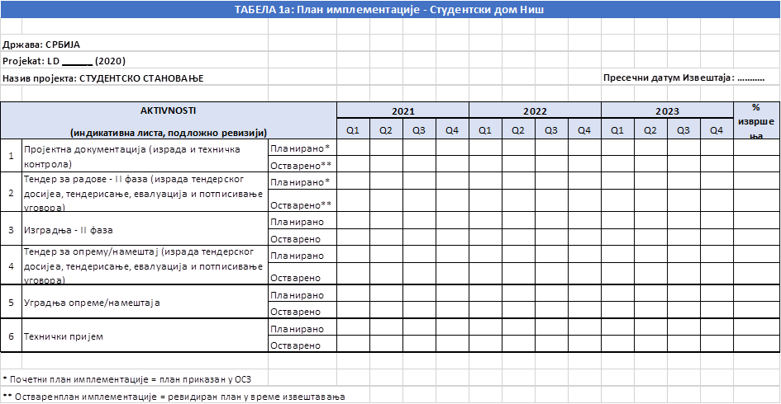
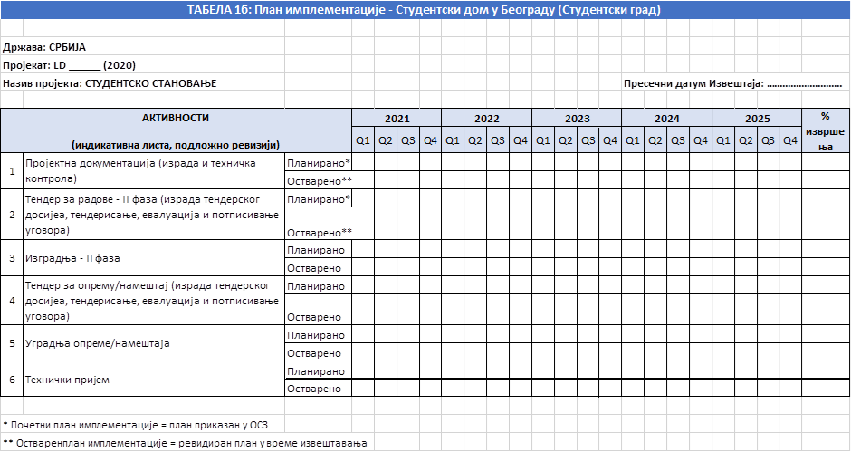
1.7 Tabela 2 – Indikatori postignuća (podnosi se na završetku projekta i, gde je moguće, na završetku projektovanja)

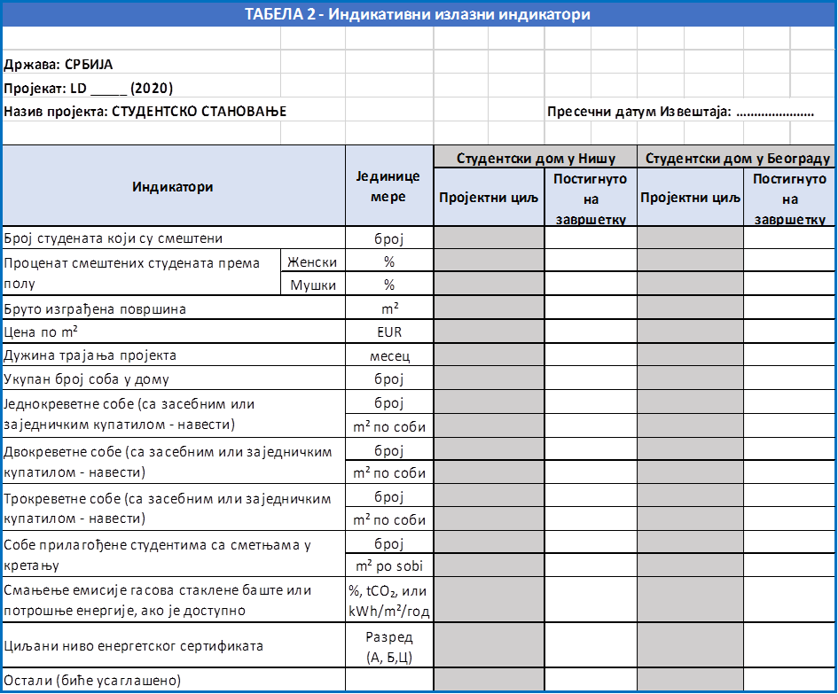

2. Finansijski izveštaj

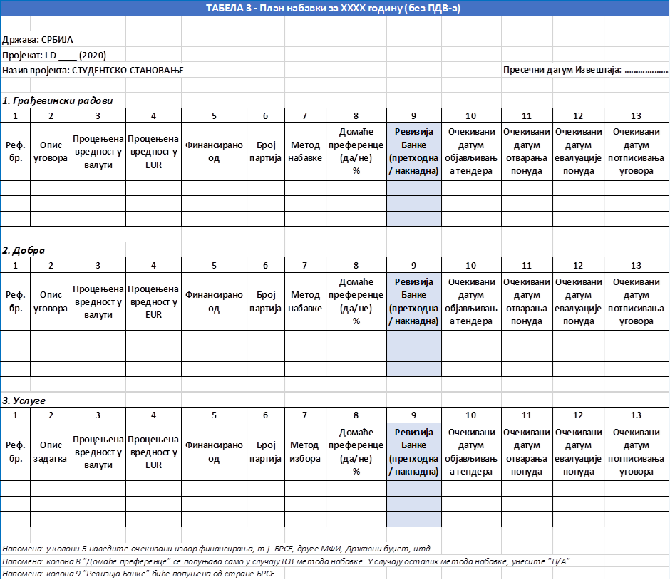
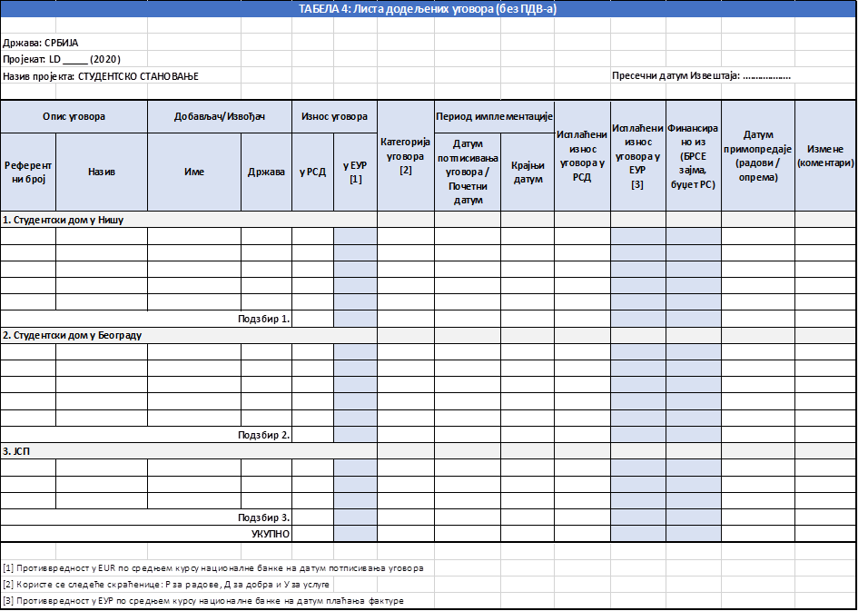
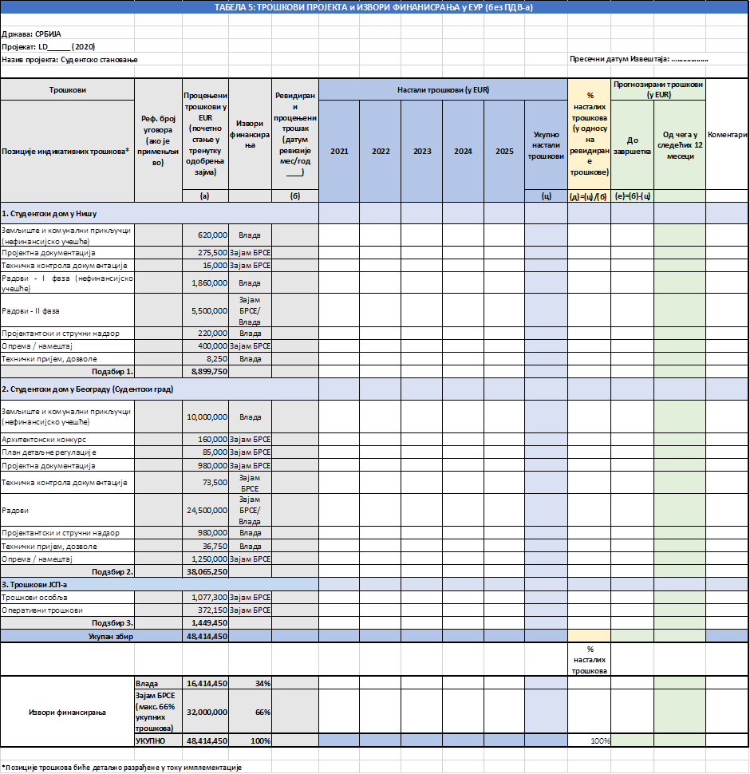

Član 3.
Ovaj zakon stupa na snagu osmog dana od dana objavljivanja u „Službenom glasniku Republike Srbije - Međunarodni ugovori”.

http://eeas.europa.eu/headquarters/headquarters-homepage/8442/consolidated-list-sanctions_en.
[In case of Sub-Tranches, a separate table shall indicate the Amount, Principal Repayment Period, Principal Repayment Date(s), Interest Rate, Interest Period, Interest Payment Dates for each Sub-Tranche.]
[In case of Sub-Tranches, a separate table shall indicate the Amount, Principal Repayment Period, Principal Repayment Date(s), Interest Rate, Interest Period, Interest Payment Dates for each Sub-Tranche.]
http://eeas.europa.eu/headquarters/headquarters-homepage/8442/consolidated-list-sanctions_en.
[У случају под-транше, посебна табела ће назначити Износ, Период отплате главнице, Датум(е) отплате главнице, Каматну стопу, Каматни период, Датуме плаћања камате за сваку под-траншу.]
[У случају под-транше, посебна табела ће назначити Износ, Период отплате главнице, Датум(е) отплате главнице, Каматну стопу, Каматни период, Датуме плаћања камате за сваку под-траншу.]

